PROJECT NAME: Edwards_188327

Edwards_chapter 16
I have corrected the style errors as followed in the below mentioned screenshots. Please check and confirm:

- <H1-INTRO> this markup are followed to-----------H1
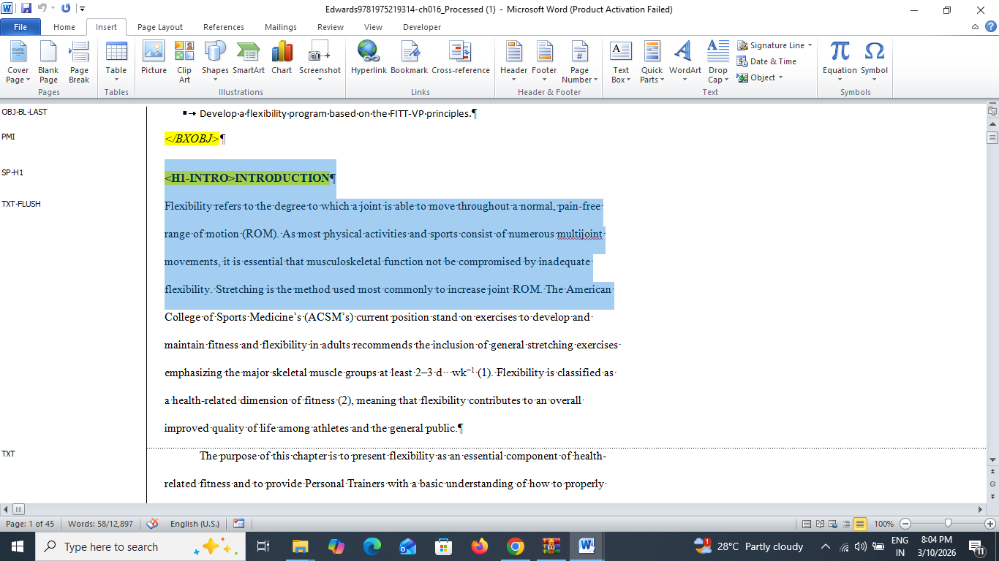
- FIG-LEG-------TXT
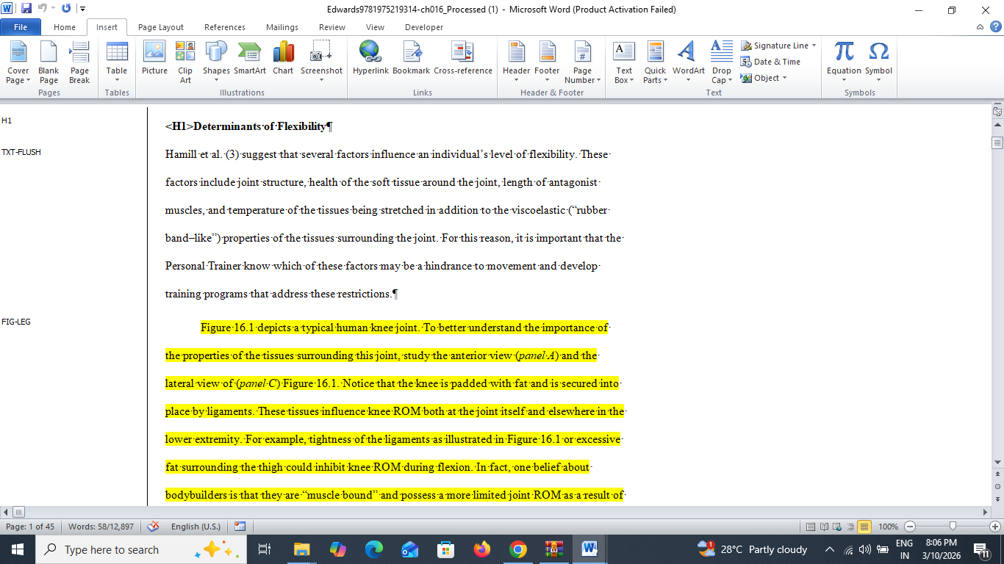
- <BXM>------- Inside the content first para are followed by BX1-TXT-FIRST
Second para are followed by BX1-TXT
<BXM>
It is also possible that injury, disease, and poor soft tissue integrity can contribute to hypermobility or excessive ROM in a joint.
</BXM>
- BL-FIRST----------BL-FIRST, BL-MID, BL-LAST

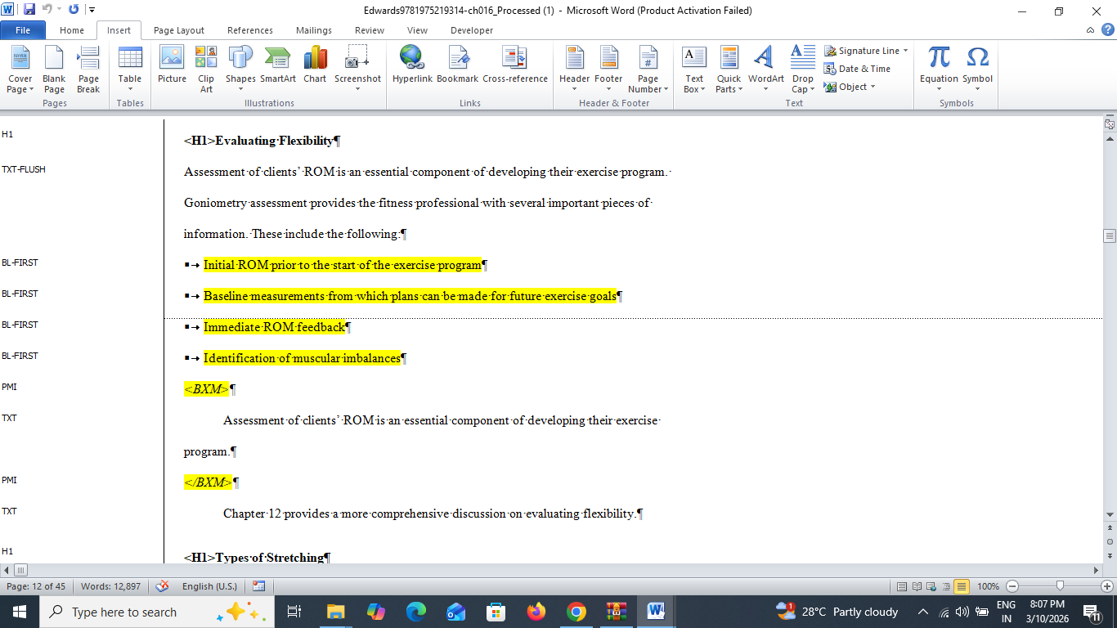
- BL-MID-----------List sequence has not proper tag (order)

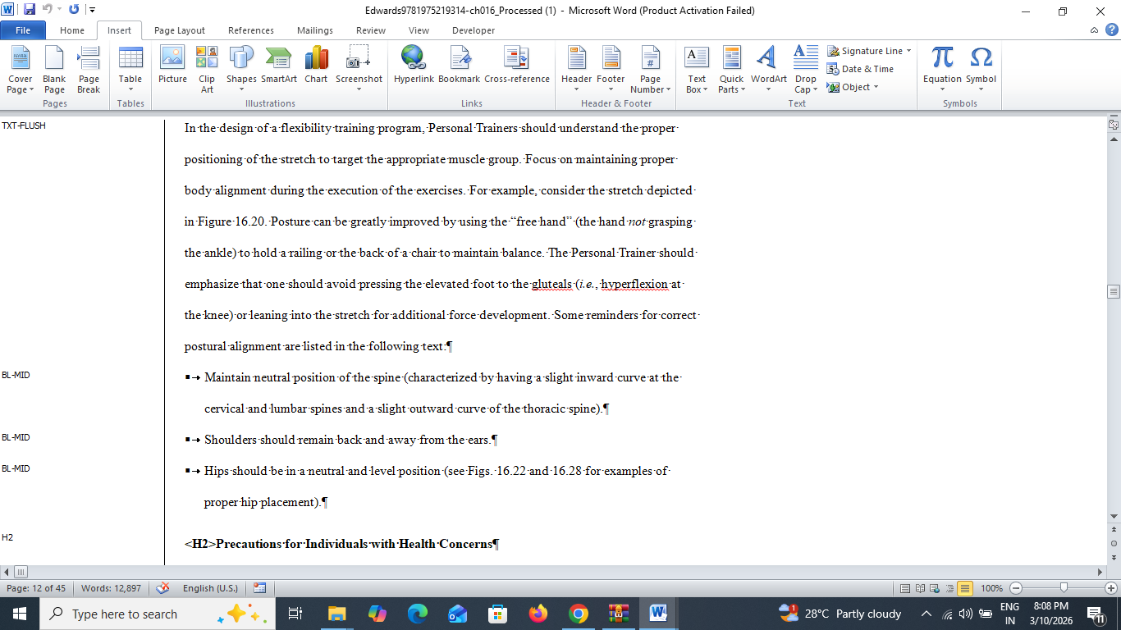
- FIGURE 16.1 (REF-N)--to----FIG-LEG
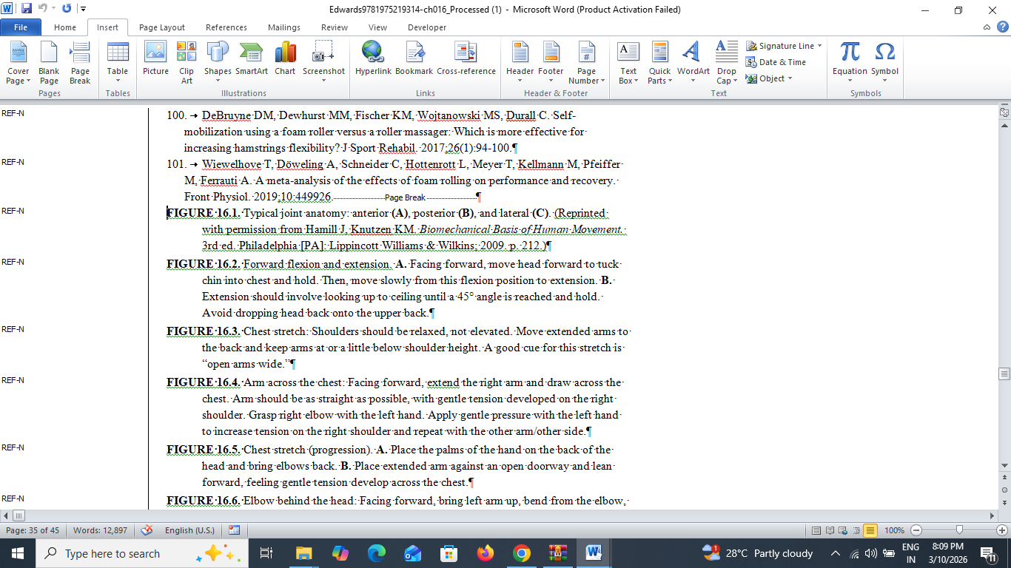

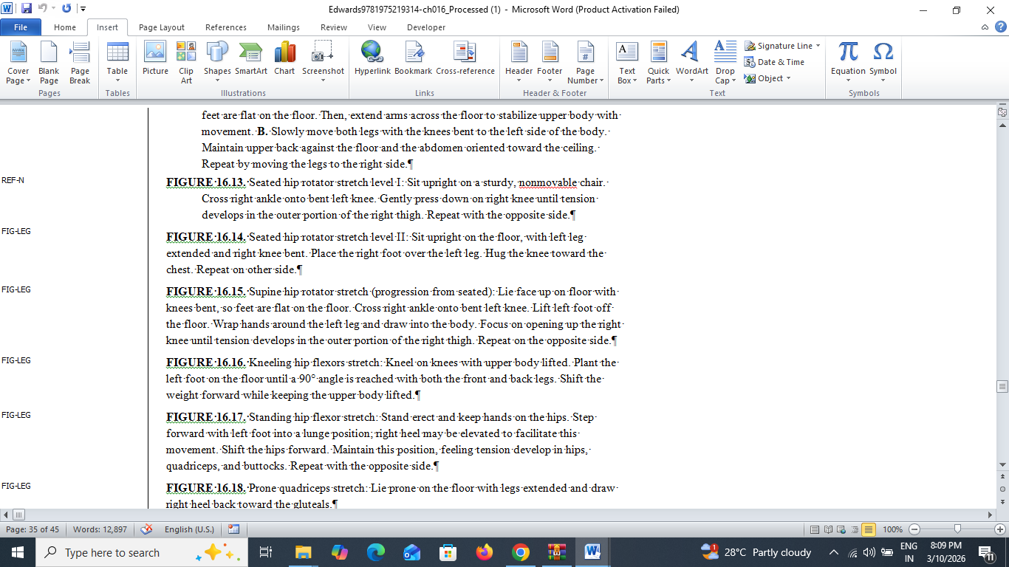
- NBX-TXT--------First para is NBX-TXT-FIRST, and next level is-----------NBX-TXT
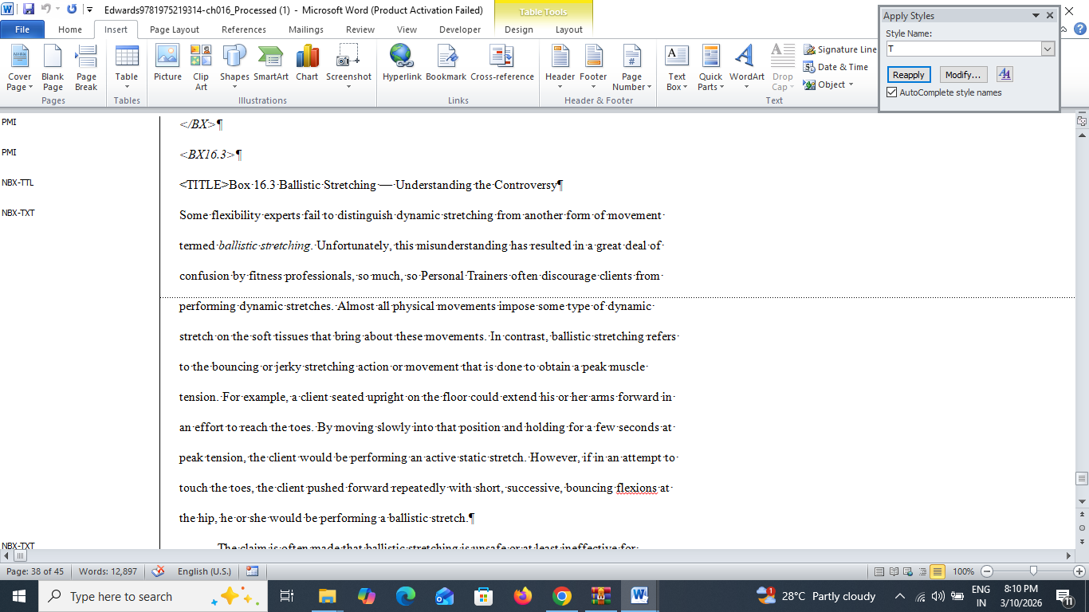

- NBX-T-----inside the NBX table are followed by Table Head--“NBX-UNT-T2”, Tablebody-“NBX-UNT”
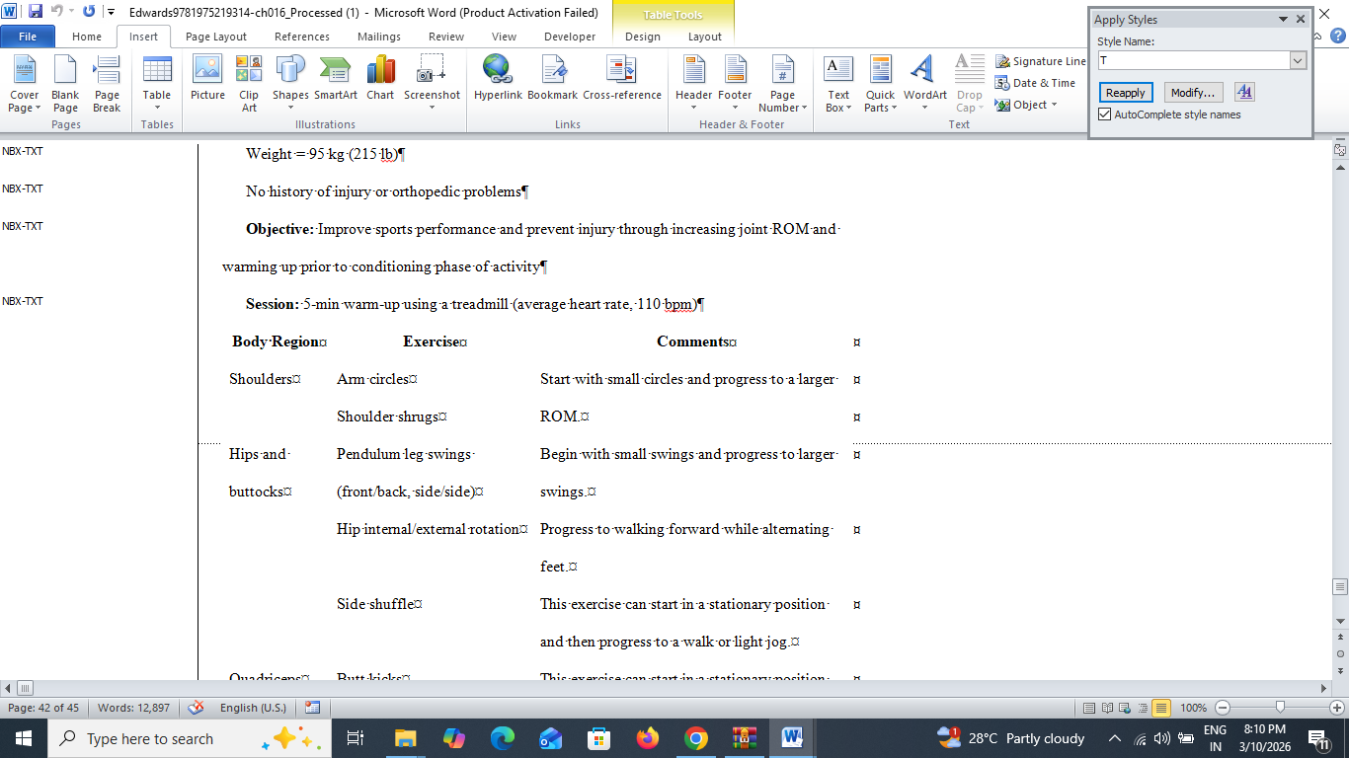
CHAPTER 8
- BL-MID--------OBJ section inside BULLET LIST terms are OBJ-BL-FIRST, OBJ-BL-MID, OBJ-BL-LAST
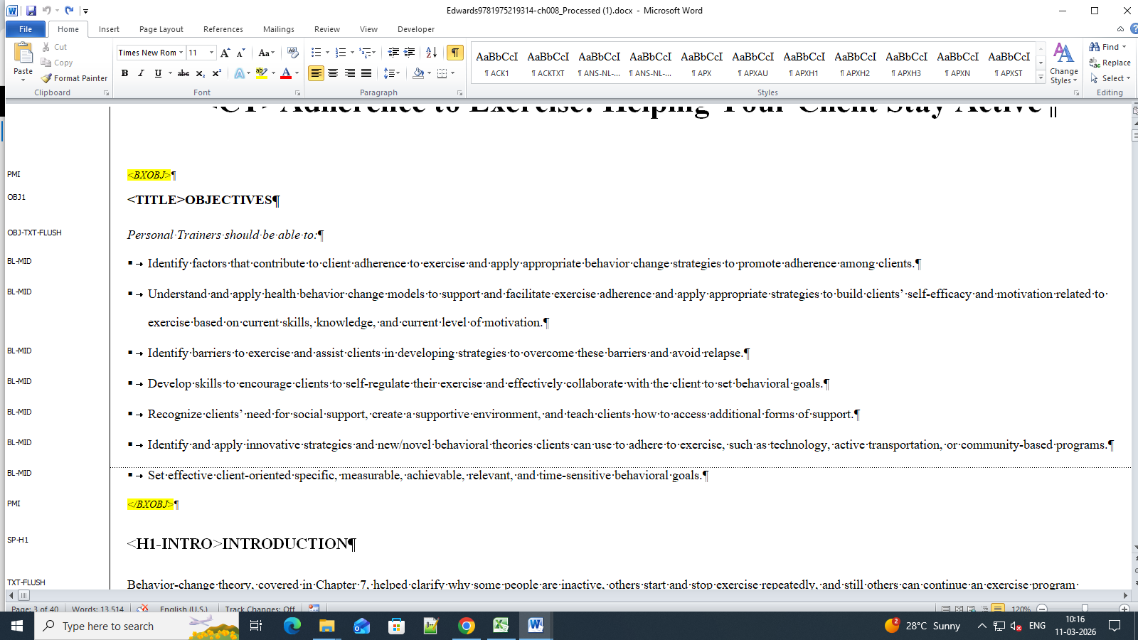

QUO------BX1-TXT-FIRST
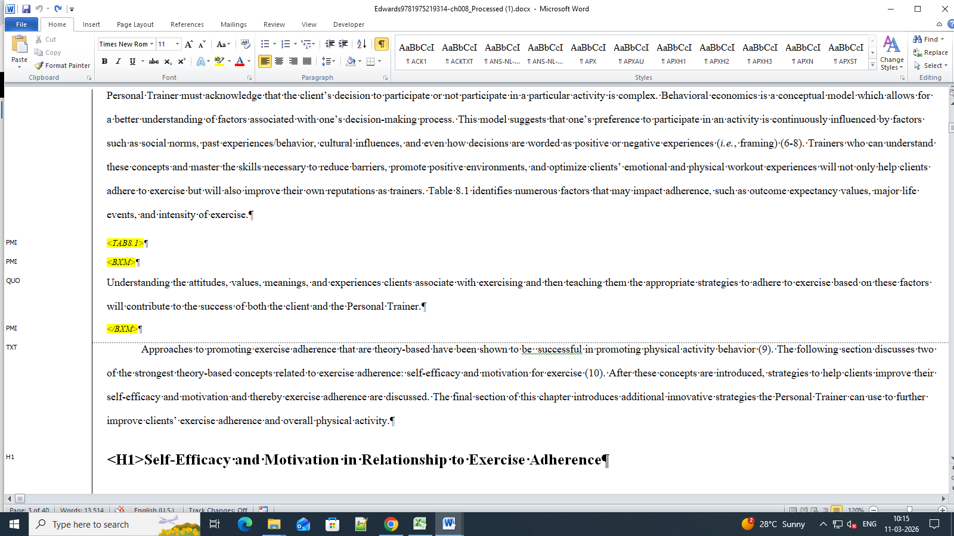
- TTL-----“Case Study” title is CS-TTL
Section inside are CS-H1, CS-TXT-FIRST, CS-TXT etc
- H1---EOC-H1
Section inside EOC -TXT-FIRST, EOC-TXT; NUMBER-LIST: EOC-NL-FIRST….. etc..
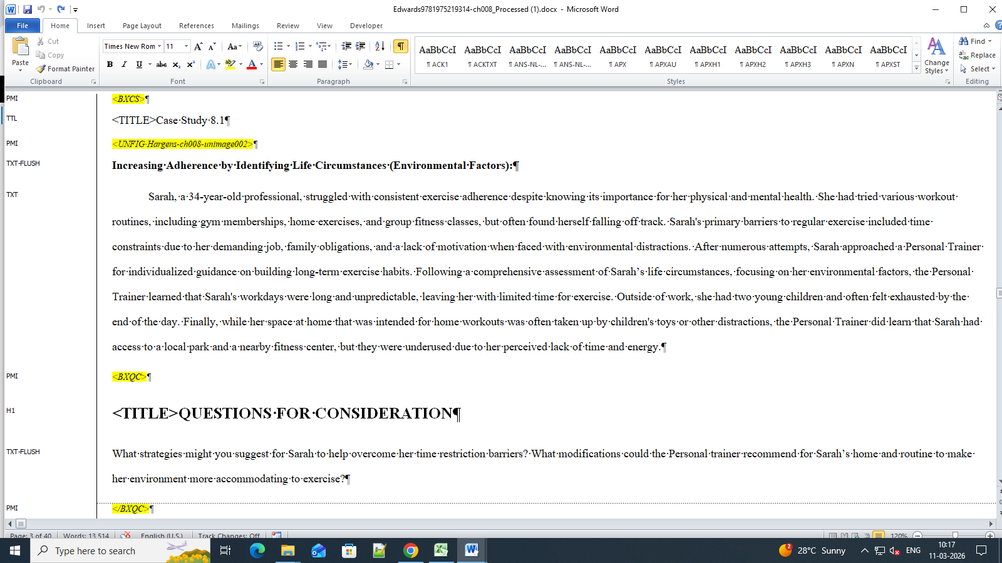

- T----TBL-MID
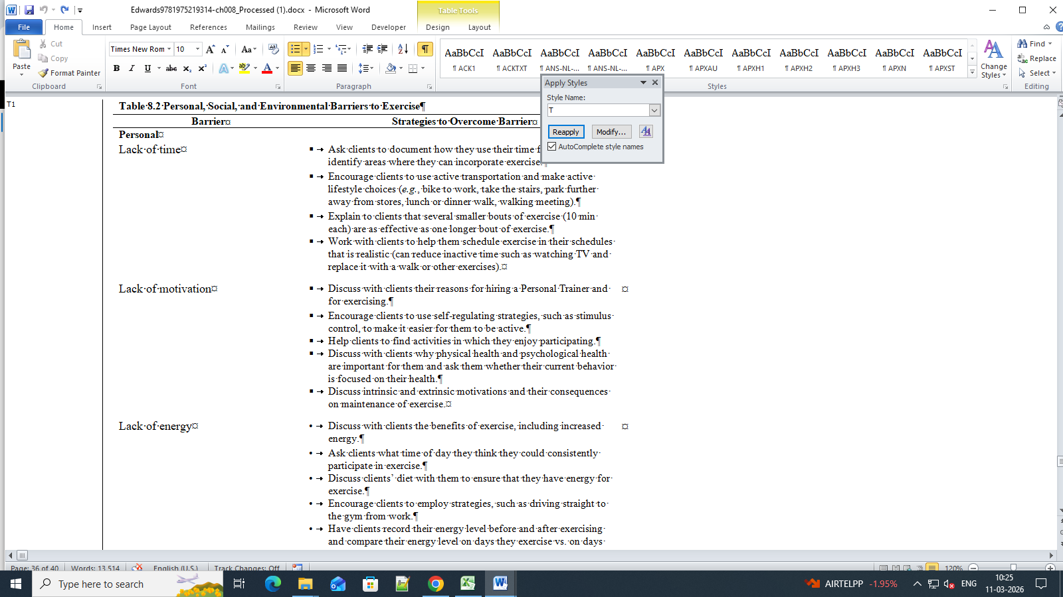
- TBL-FIRST-------Not necessary For First & Last Inside Table just TBL-MID
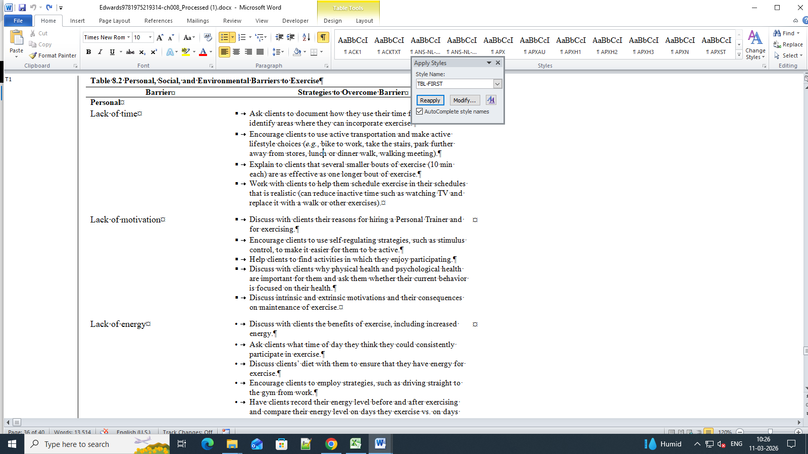
- TBL-LAST-------TBL-MID
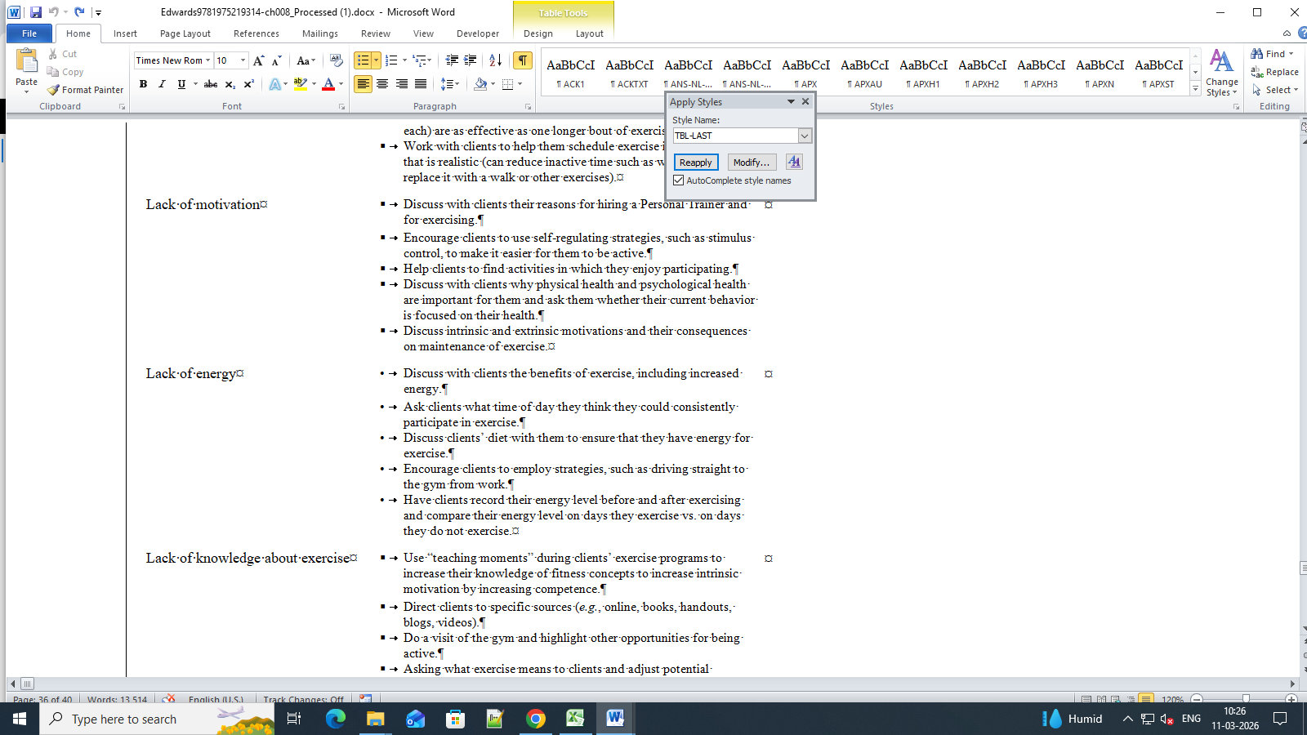
- T----T4
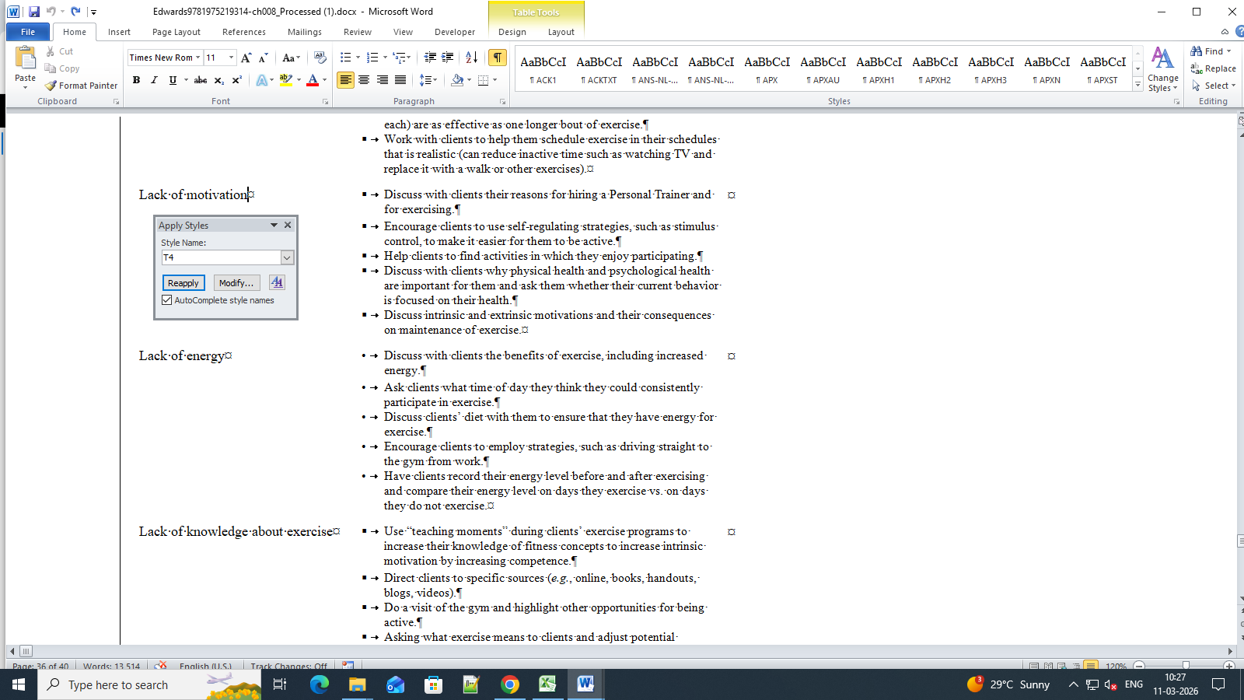
- BL-FIRST-------TXT

- BL-FIRST--------BX1-TXT-FIRST

- QUO----BX1-TXT-FIRST
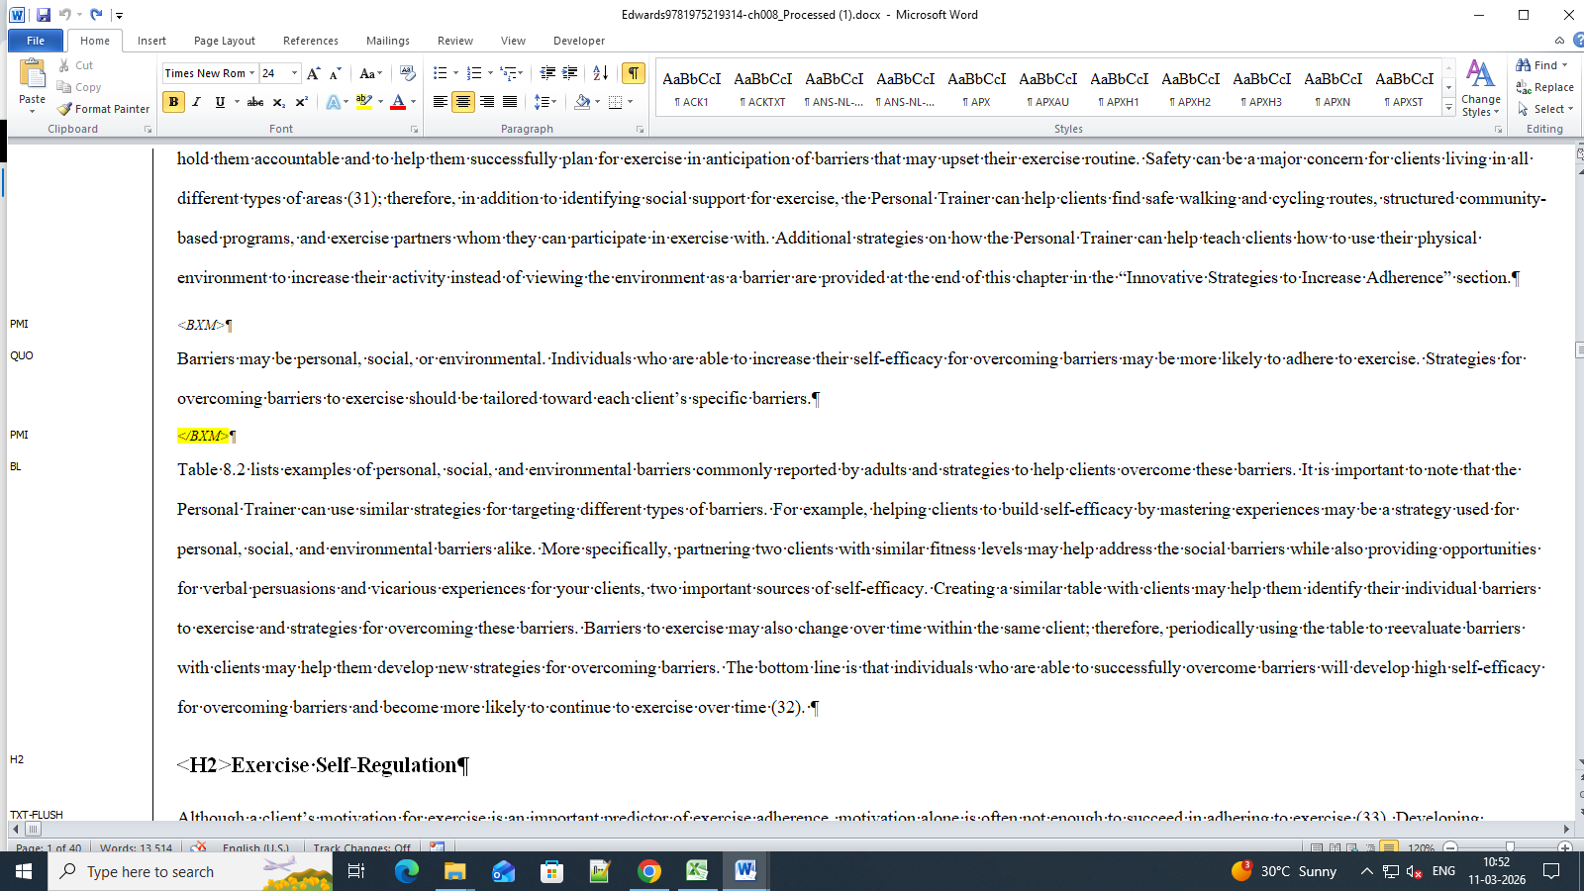
- H1----Summary Also -- EOC-H1
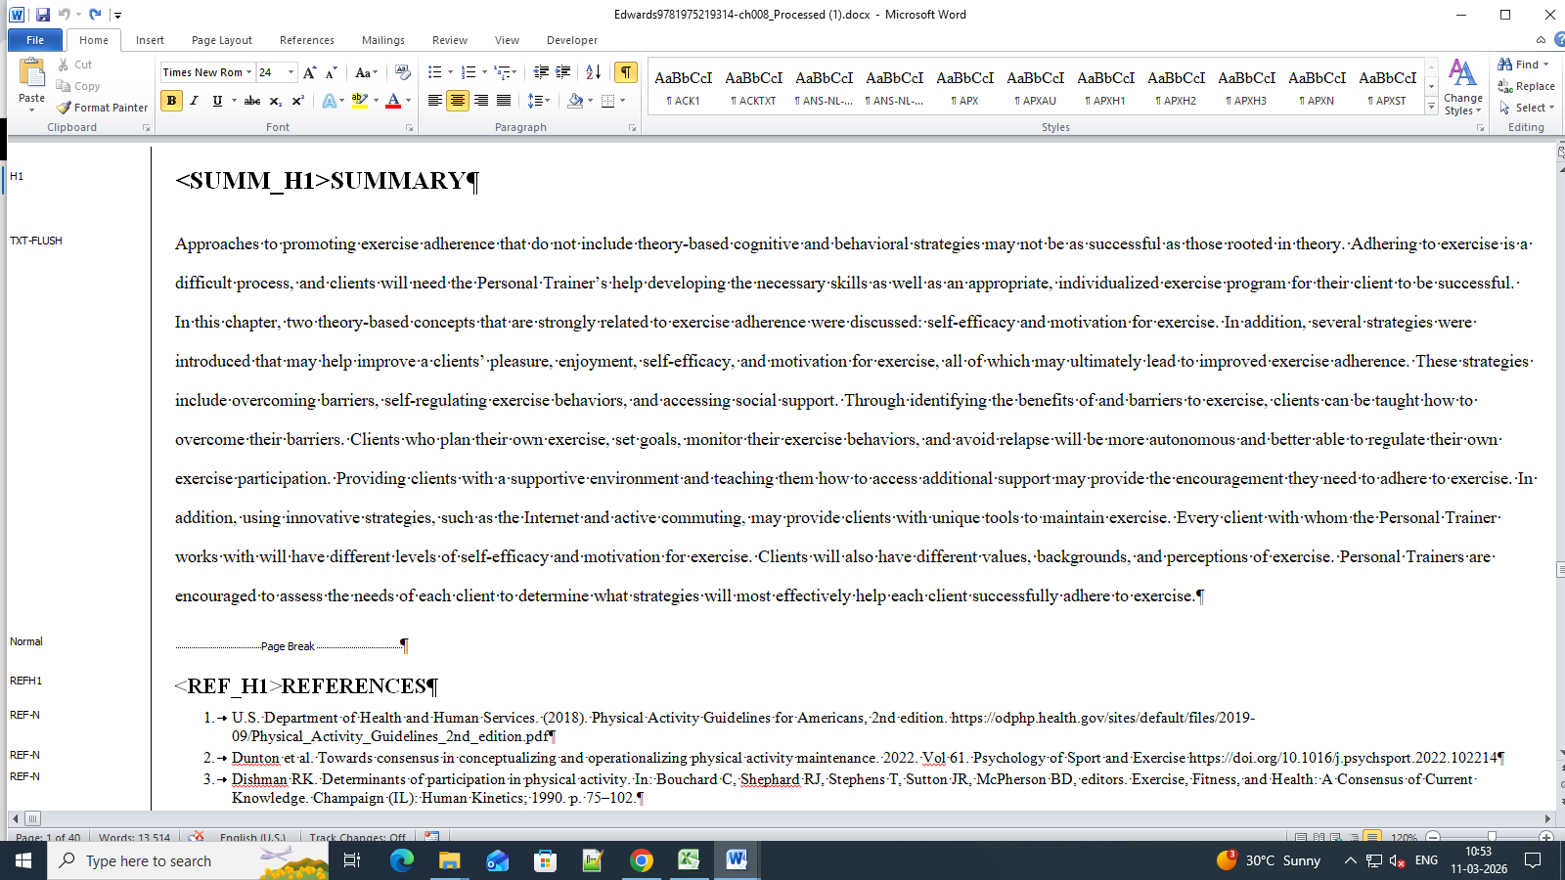
Chapter 6

- BL-FIRST--------NL-FIRST, NL-LAST
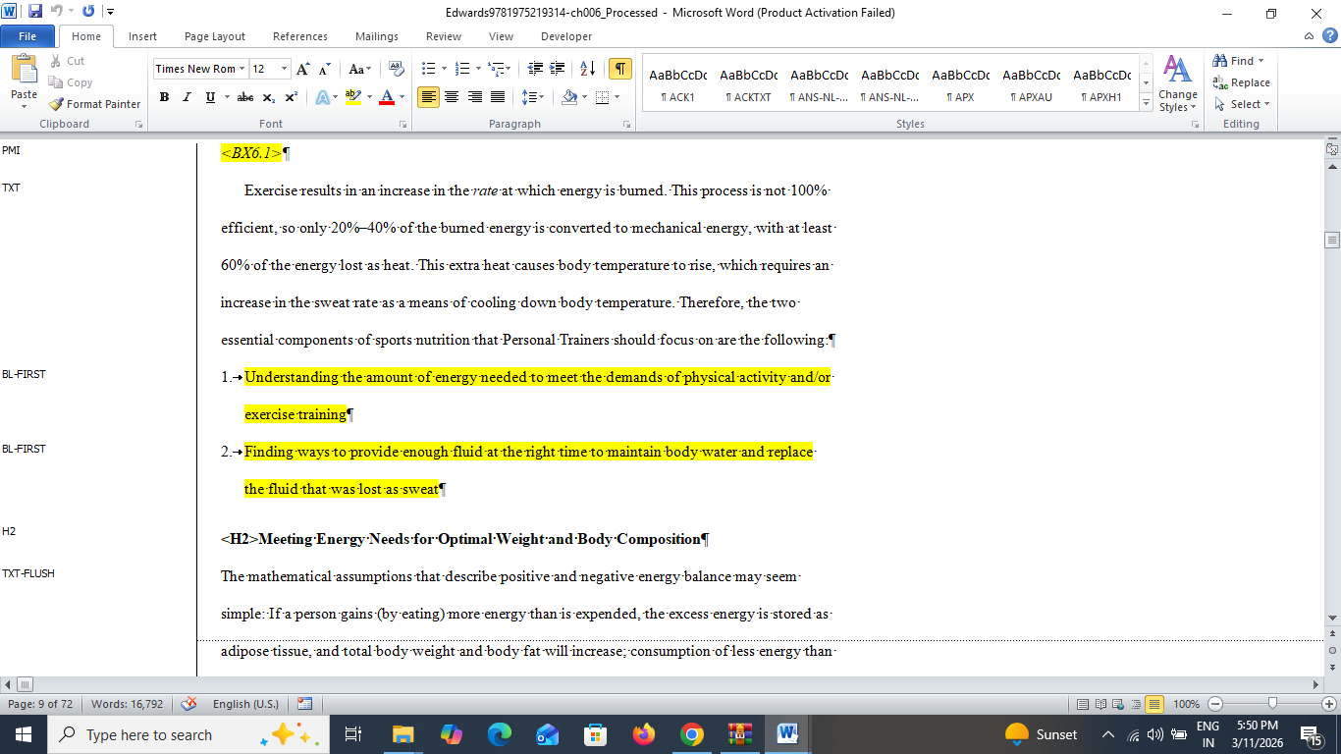
- BL-MID----------BL-FIRST, BL-MID, BL-LAST
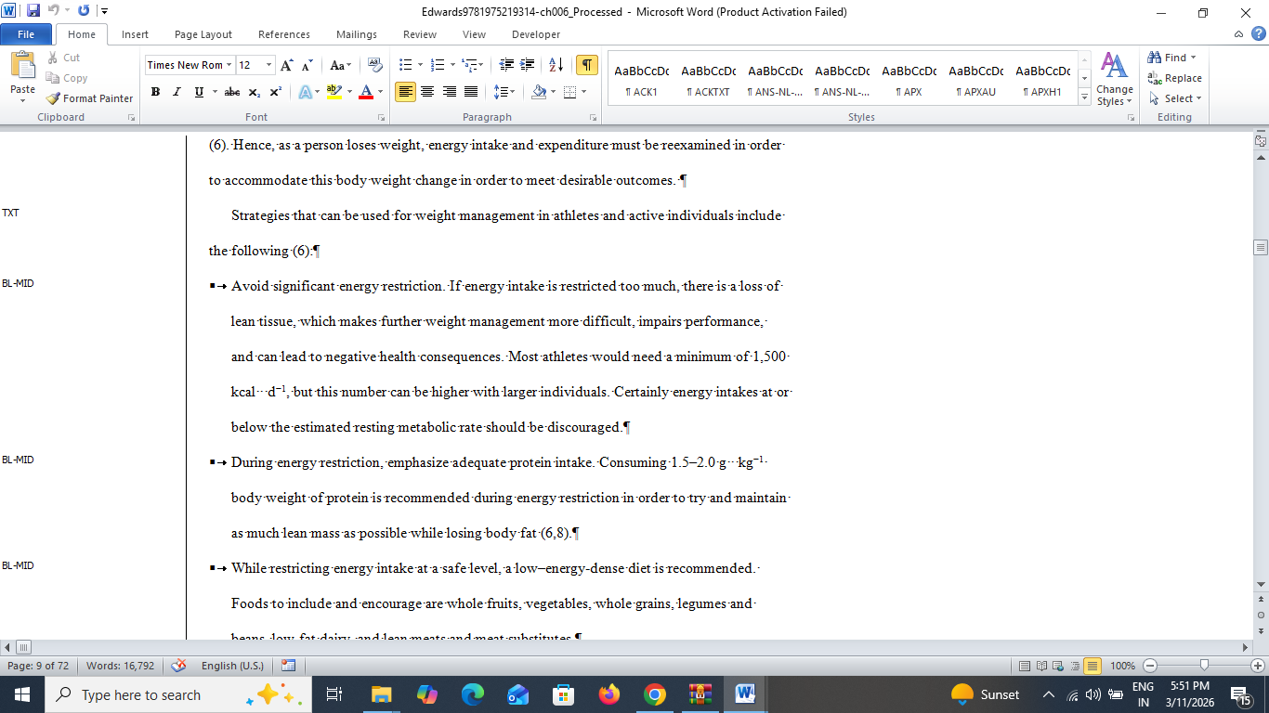

- NORMAL-------EQ-MID
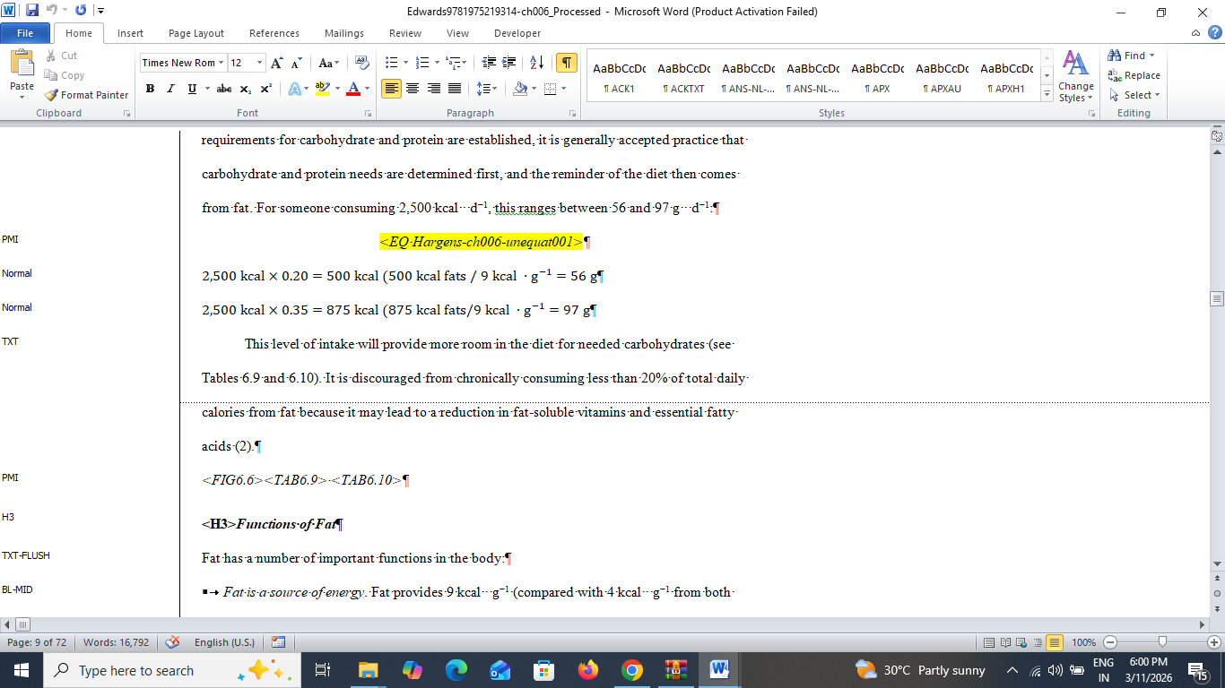

- EXT-ONLY-------BX1-TXT-FIRST
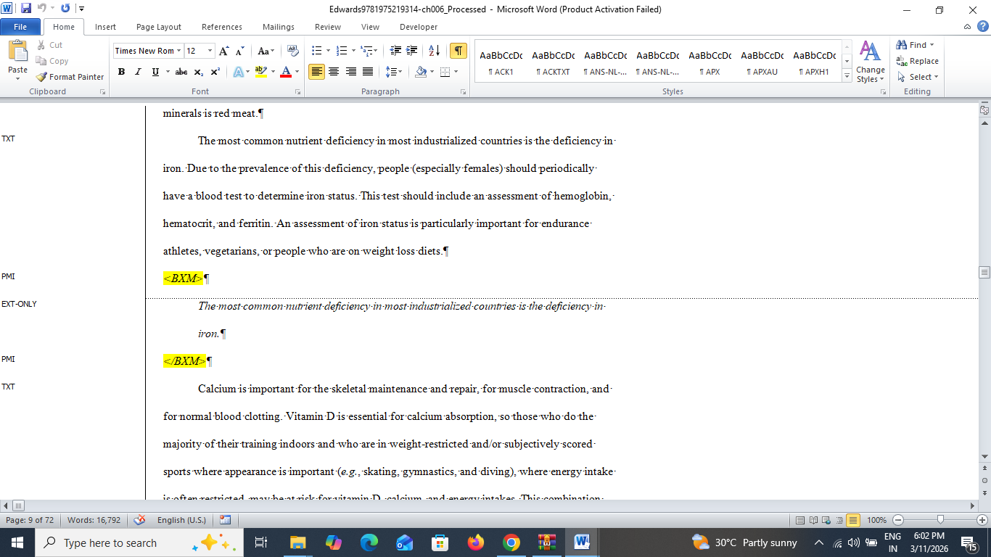

- BL-FIRST---------BL-MID
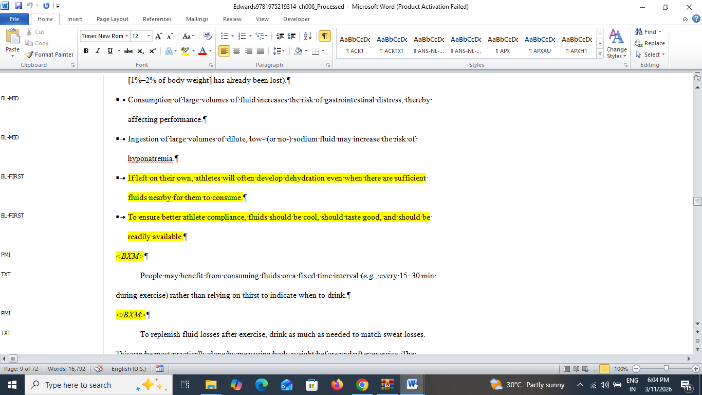
- BL-FIRST------BL-FIRST, BL-MID, BL-LAST
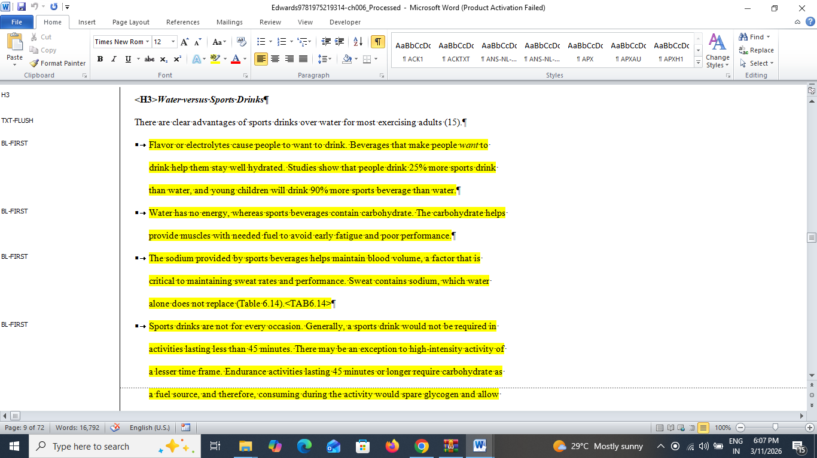
- BL-FIRST----NL-FIRST, NL-MID, NL-LAST
- BL-FIRST----BL-FIRST, BL-MID, BL-LAST
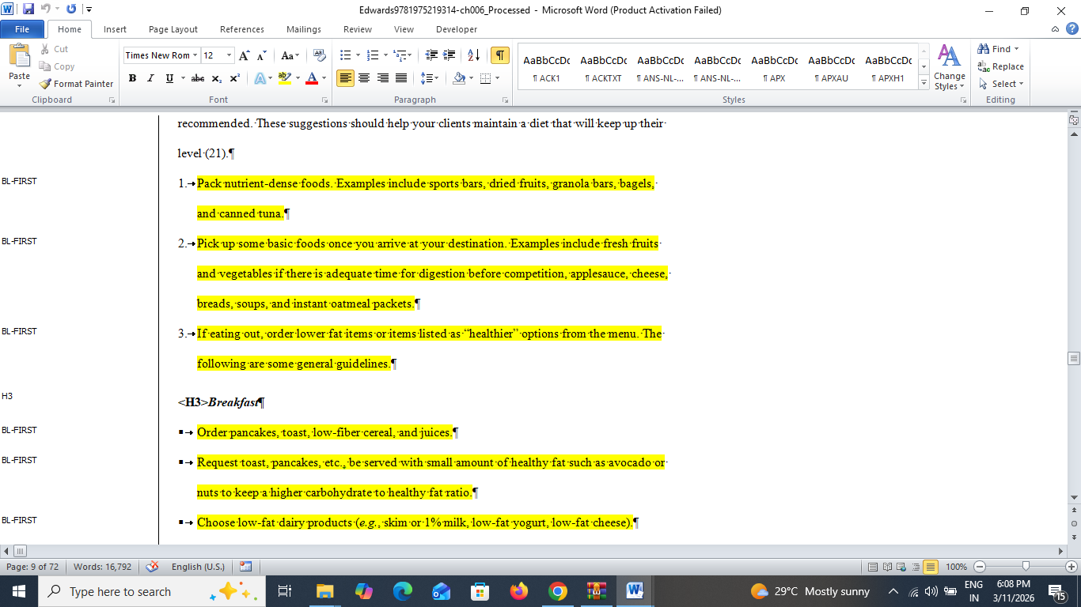
- EOC-H1----EOC heading section should add like: EOC-TXT-FLUSH, EOC-TXT
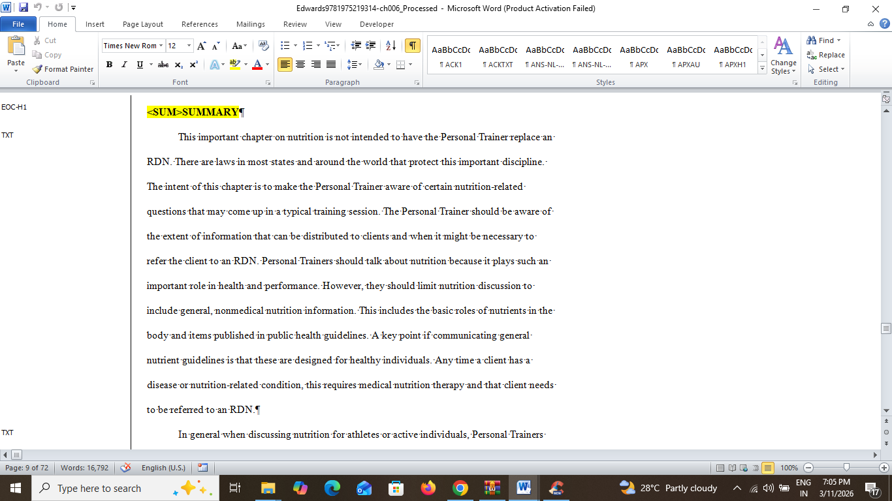

Chapter 11

- TXT-FLUSH----Txt-Flush After paragraph should be -TXT
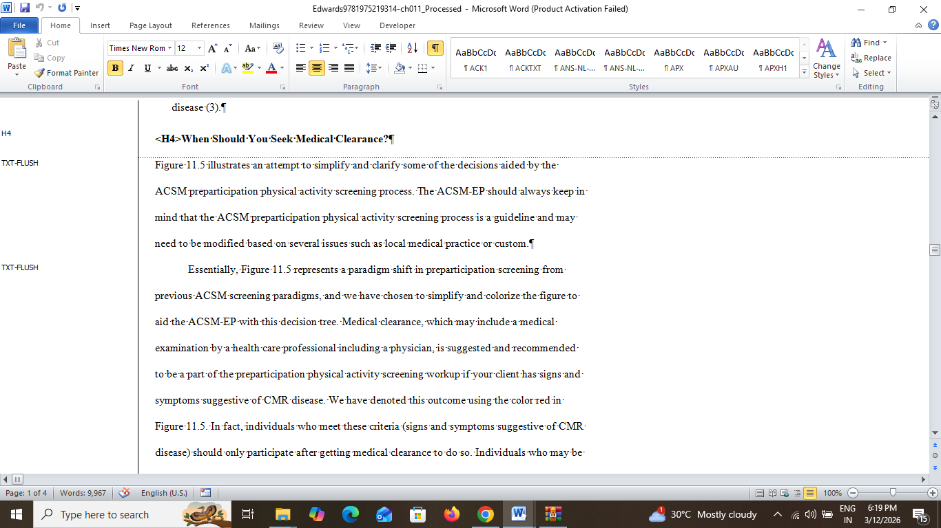
- TTL----CS-TTL
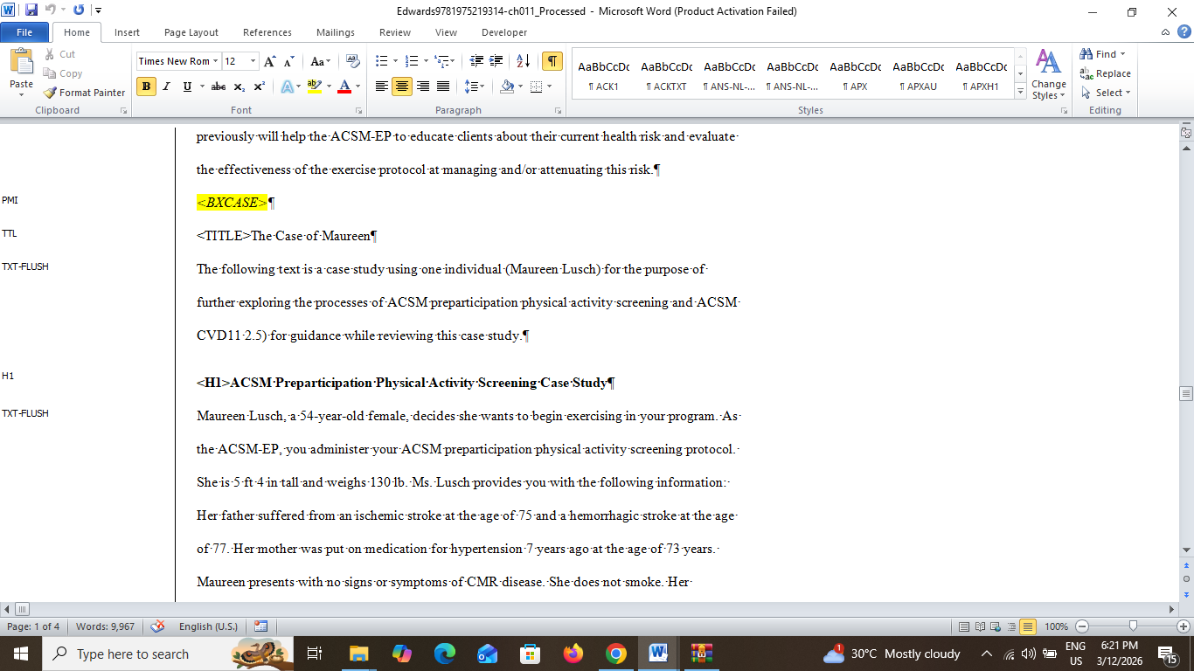

CHAPTER 22
- L1---TXT-FLUSH
- BL-FIRST----NL-FIRST
- BL-FIRST----NL-MID

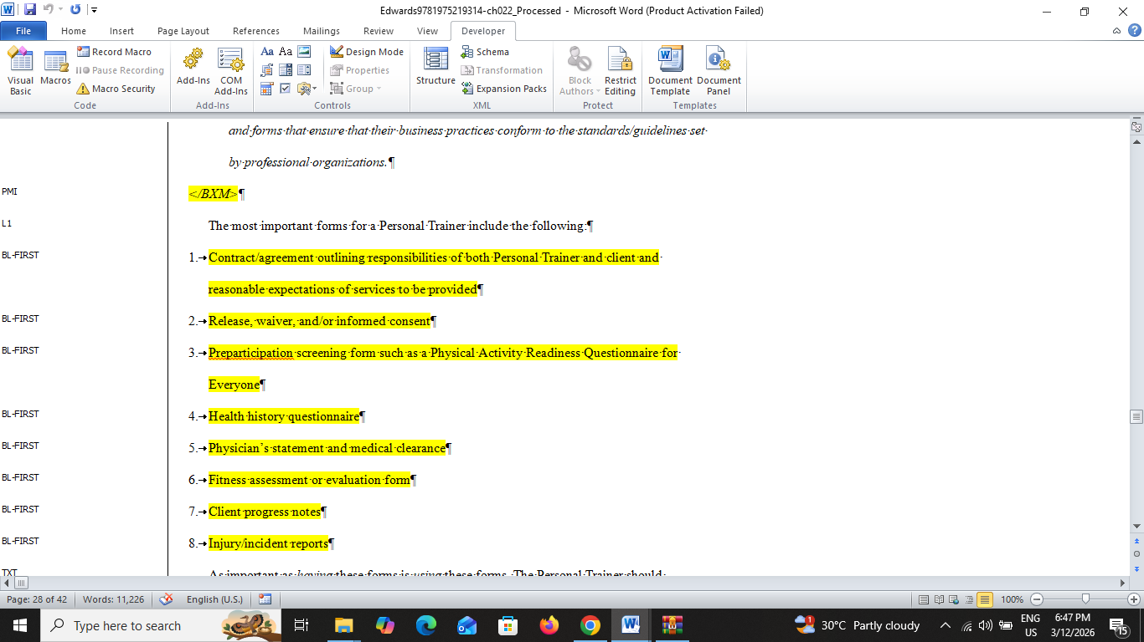
- L1-------TXT
- FIRST BULLET LIST----------BL-FIRST
- MID BULLET LIST ---------BL-MID
- LAST BULLET LIST ----------BL-LAST

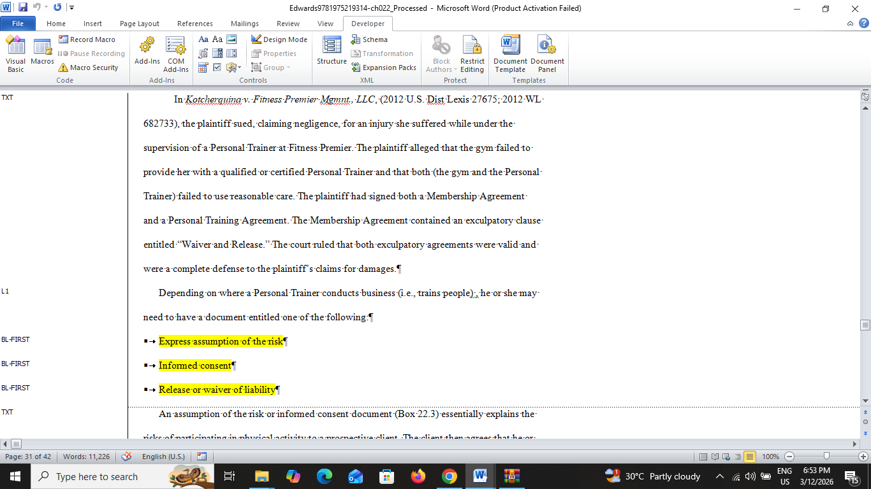
- BL-FIRST---------REF-N
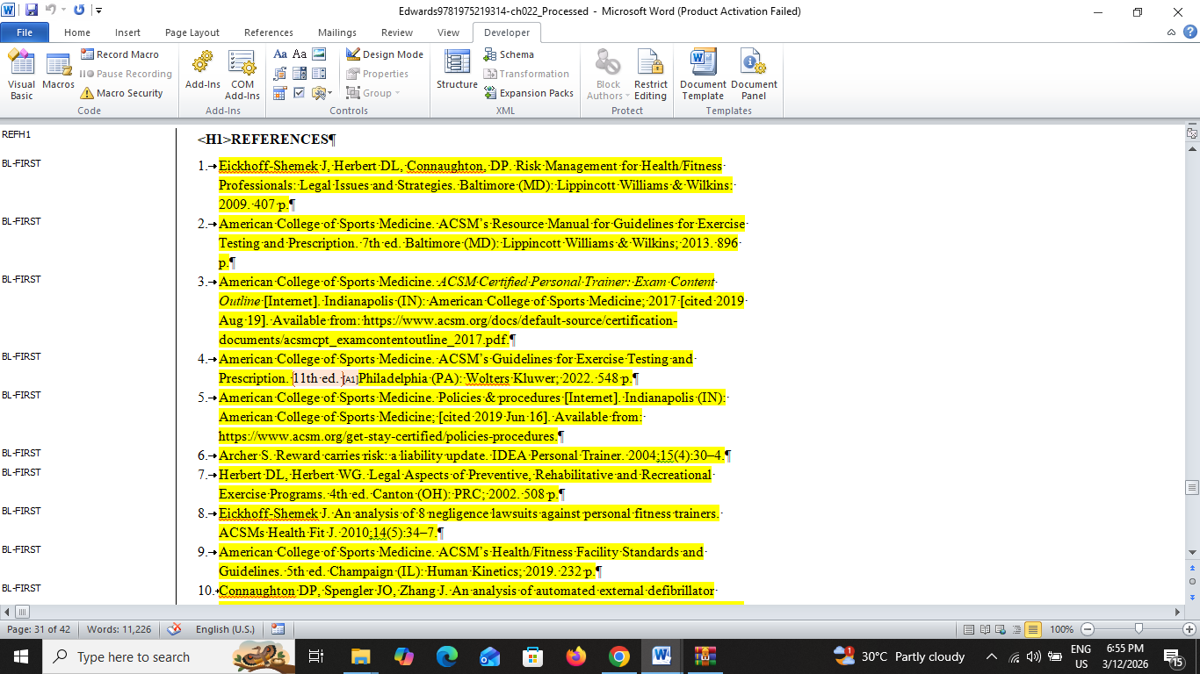

- TSN-------NBX-SRC
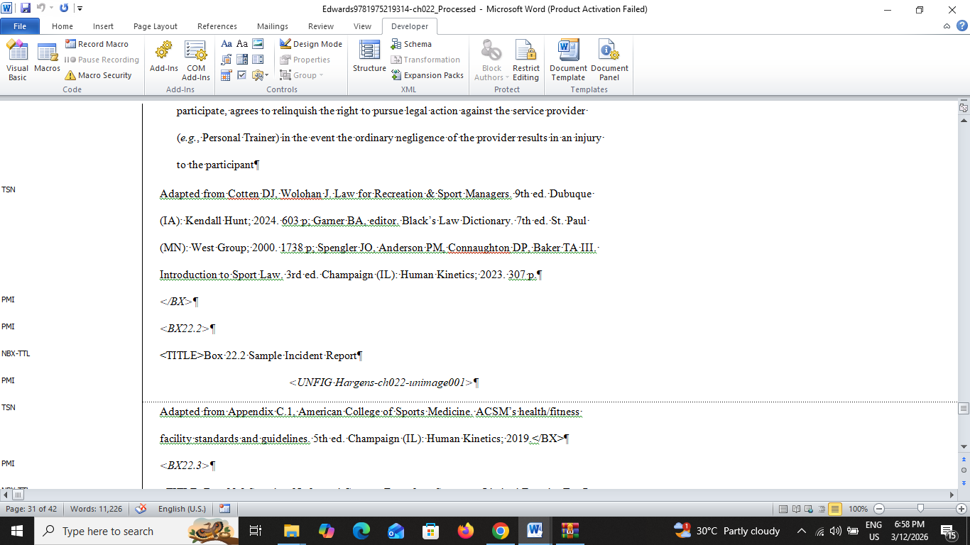
- BL-FIRST----NBX-NL-FIRST
- NBX-TXT-----NBX-NL-TXT
- BL-FIRST----NBX-NL-MID
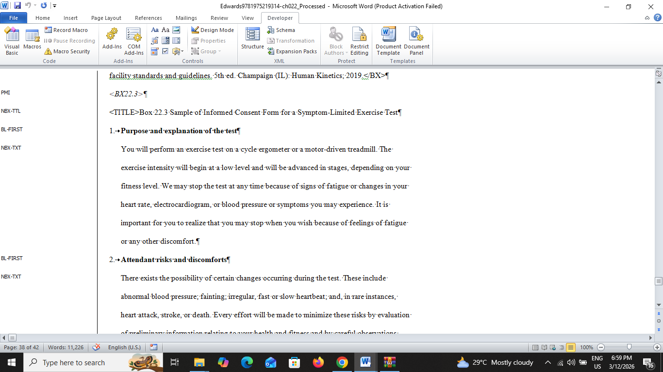

PROJECT NAME: Abuhamad_188231
Tool common issue:
folder structure issue
WHEN file Two time run output name are same for example:
Abuhamad9781975242831-ch003_Processed.docx
Abuhamad9781975242831-ch003_Processed.docx

CHAPTER 3
- Chapter number & title not properly tagged.
FORMATTING ISSUE….TEXT COLOR CHANGE
ALSO Bold added table captions
<TAB 3-1> -italic Added

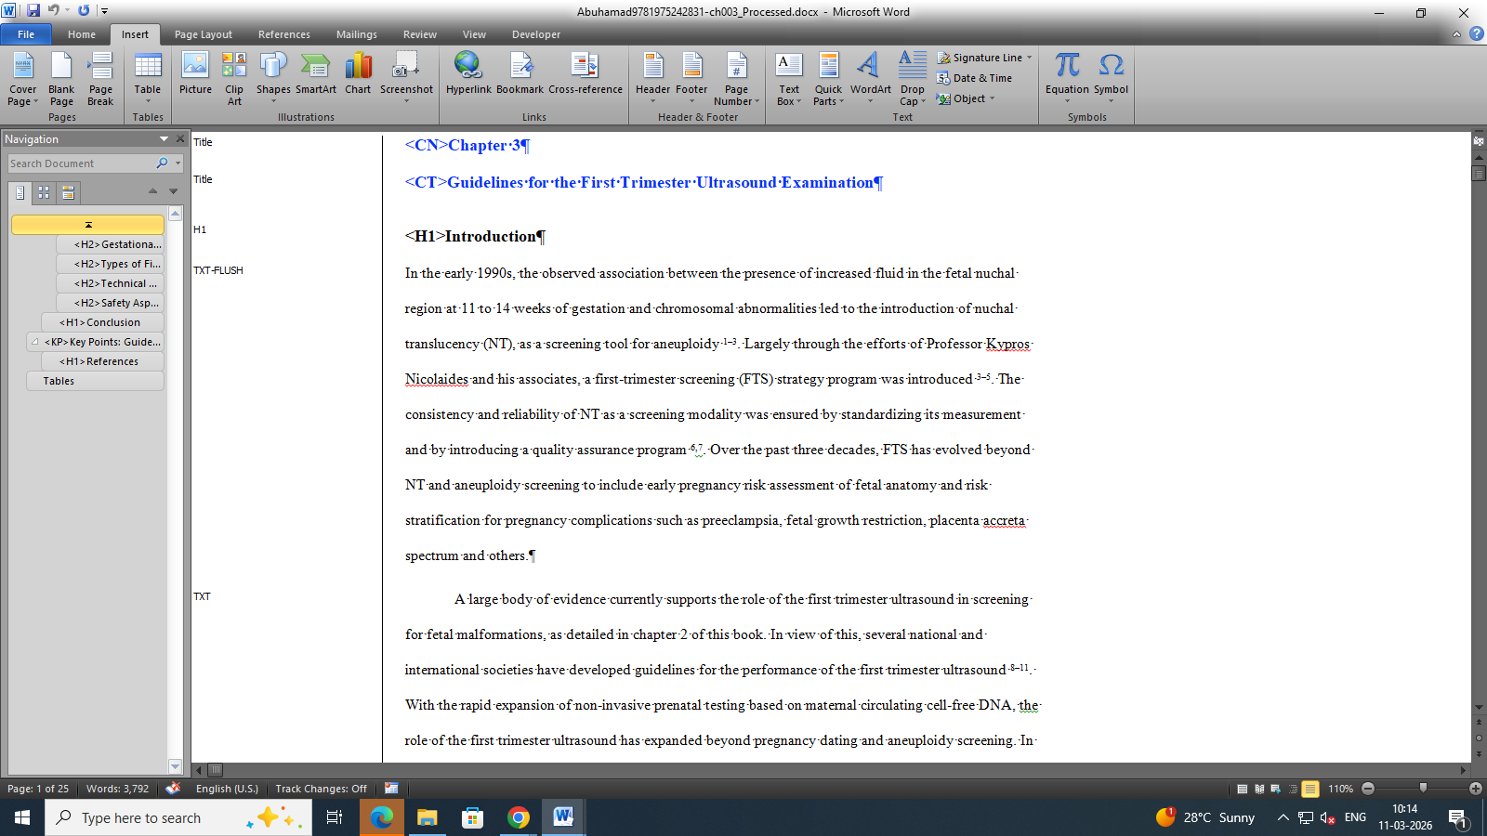

- <TAB 3-3><TAB 3-4> --PMI Not T1
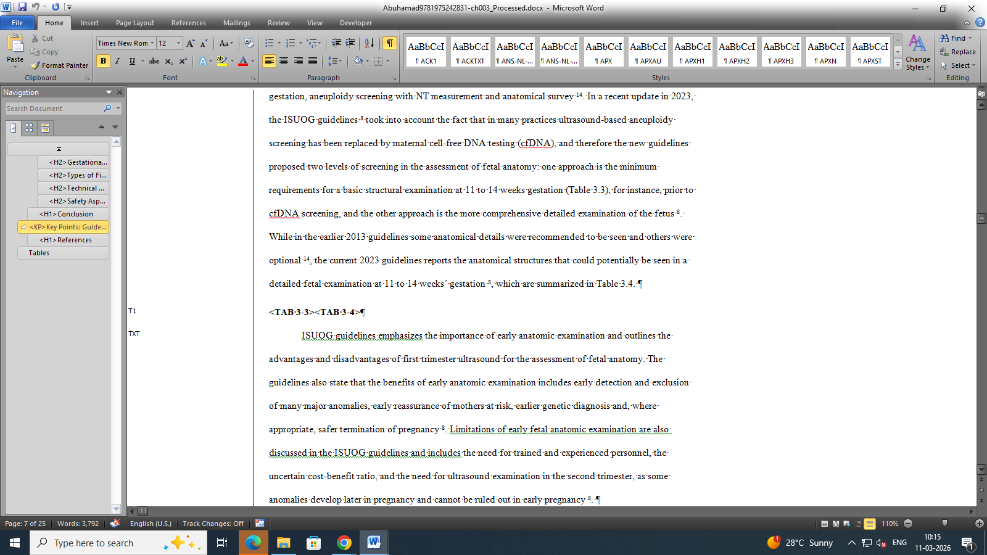

- Before reference heading starts with key point this title should be KT1
  - title inbetween section should add “KT” …Example: List style: KT-UL-FIRST…. KT-UL-MID, KT-UL-LAST

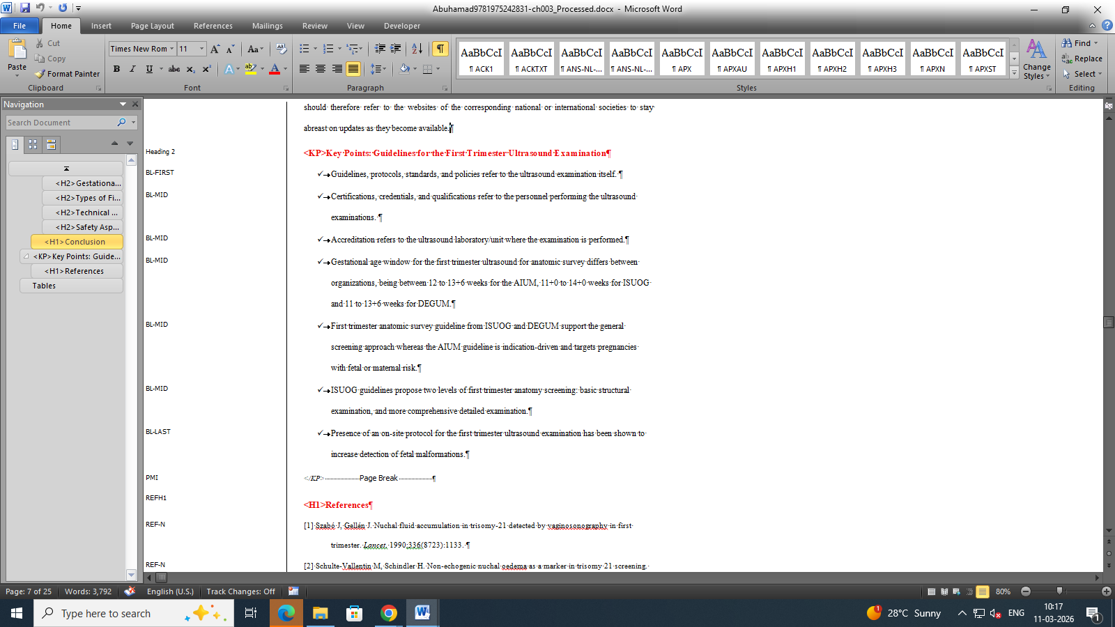

- TABLE INSIDE REF-N Style here

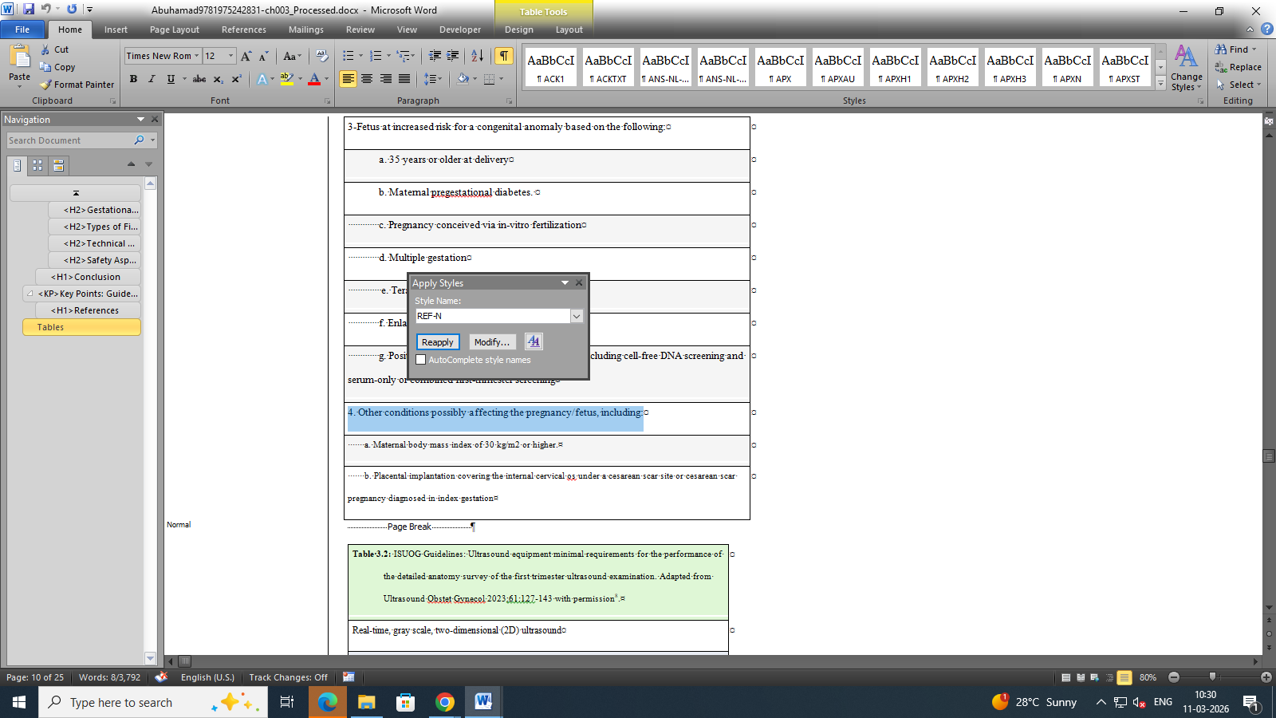
INSIDE THE TABLE style captured generaly “T” it a list type inside the table should be NUMBER: TNL-MID, BULLET: TBL-MID, ALPHABETICAL: TLL-MID…..also sublists are TNL2-MID, TBL2-MID ETC...
- Table 2 & 3 Caption tagged wrongly

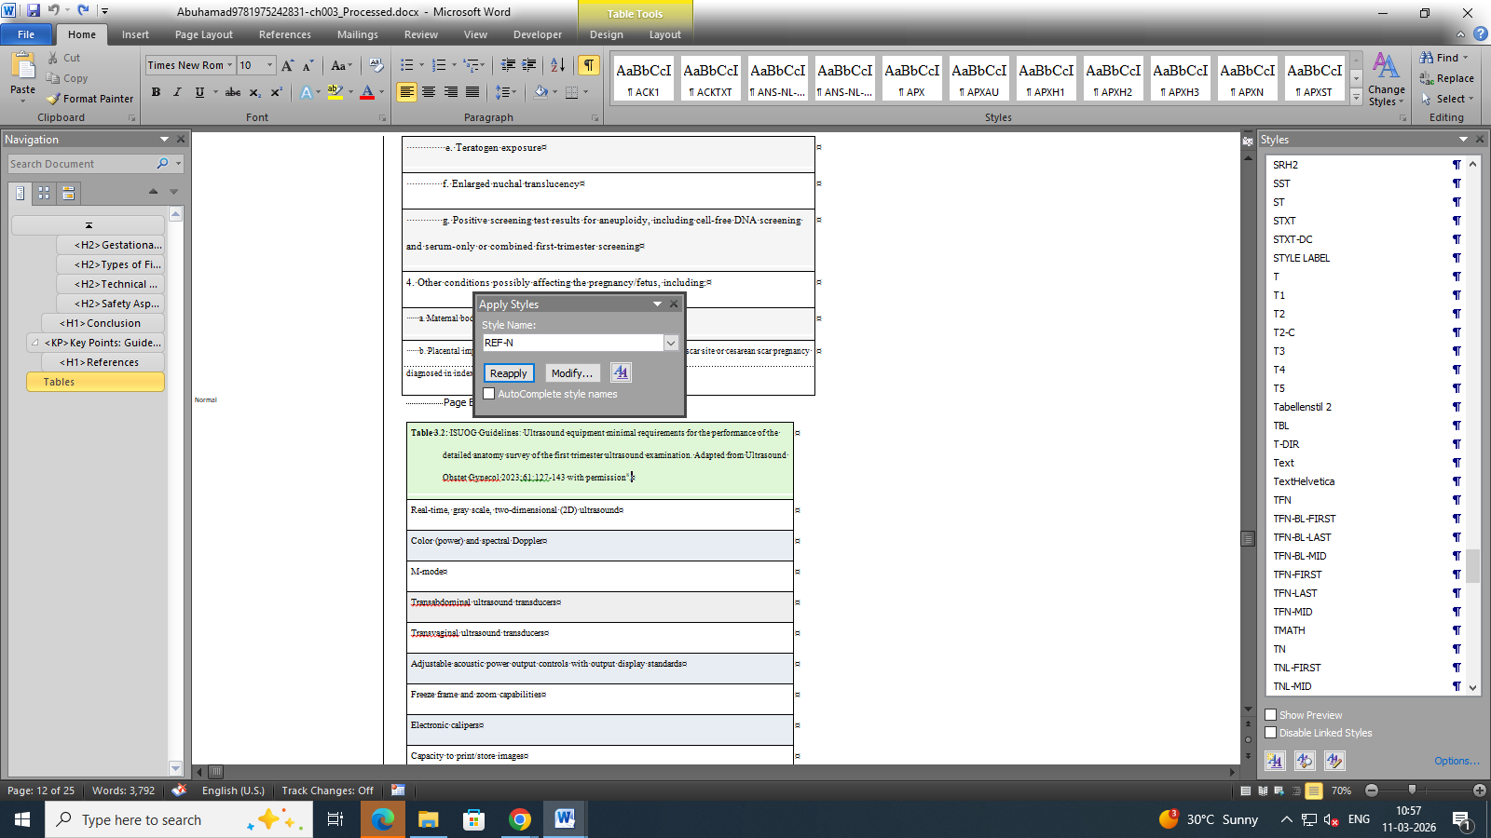

- Below term are “T”
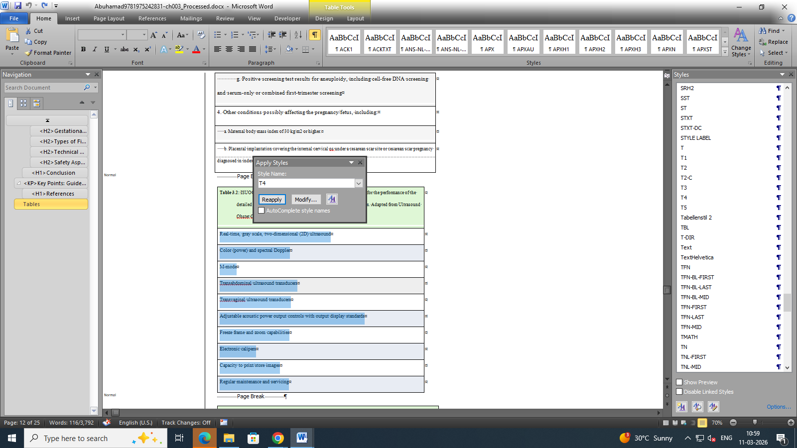

- first column with bold are captured “T4” its also “T”
  - table caption is “T1”
  - TABLE HEAD ARE “T2”
  - TABLE SECTION HEAD ARE “T3”
  - TABLE CONTENT ARE “T”
  - TABLE LIST ARE “TNL-MID” ETC…
This format is appropriate for the Number table.
Many table are wrongly tagged please check throughout.
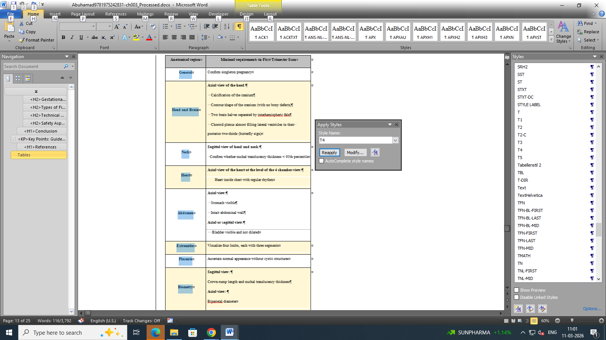

CHAPTER 14

- List start with first:
LABEL:
1.aaaa-----NL-FIRST
2.AAAA—NL-MID
3.3333----NL-LAST

a. Apple → LL-FIRST
b. Banana → LL-MID
c. Mango → LL-LAST

• Red → BL-FIRST
• Blue → BL-MID
• Green →BL-LAST

I. Planning → OL-FIRST
II. Development → OL-MID
III. Testing → OL-LAST

i. Apple → OL-FIRST
ii. Banana → OL-MID
iii. Mango → OL-LAST

Unlabel: [IDENTIFY TO INDENTATION]
Introduction → UL-FIRST
Background → UL-MID
Methodology → UL-MID
Conclusion → UL-LAST
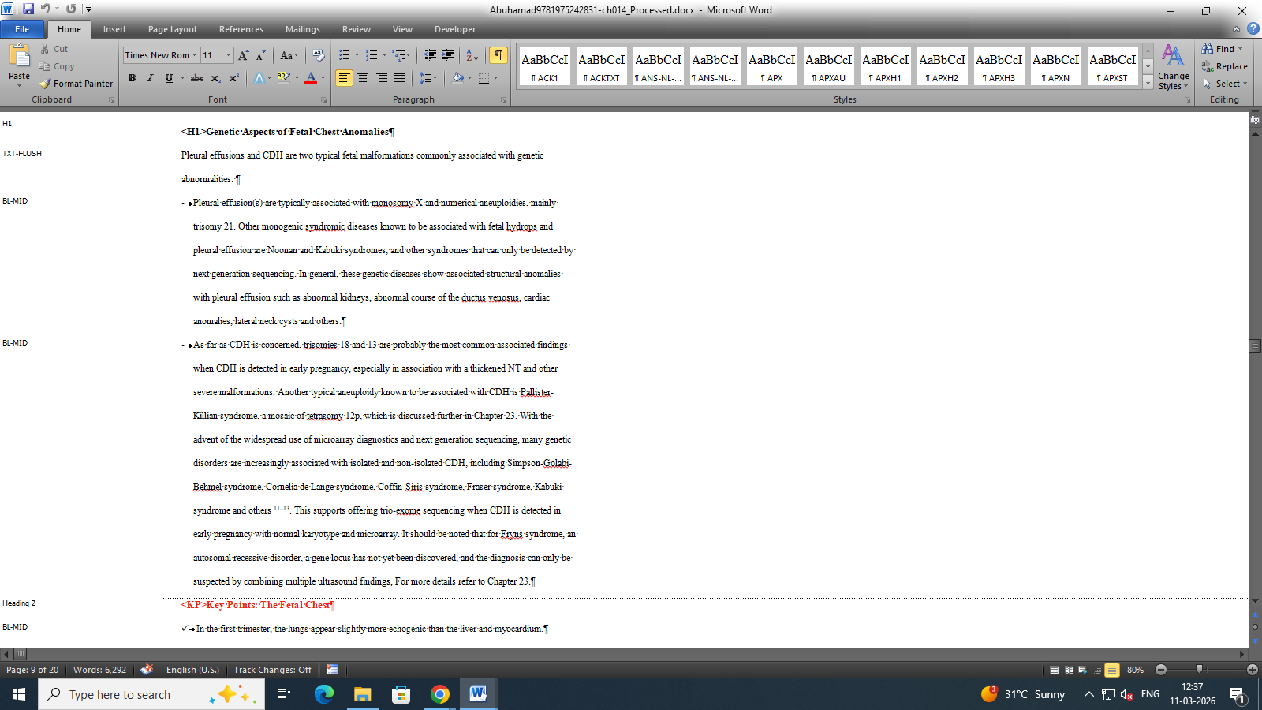

- fig caption are followed to “FIG-LEG”
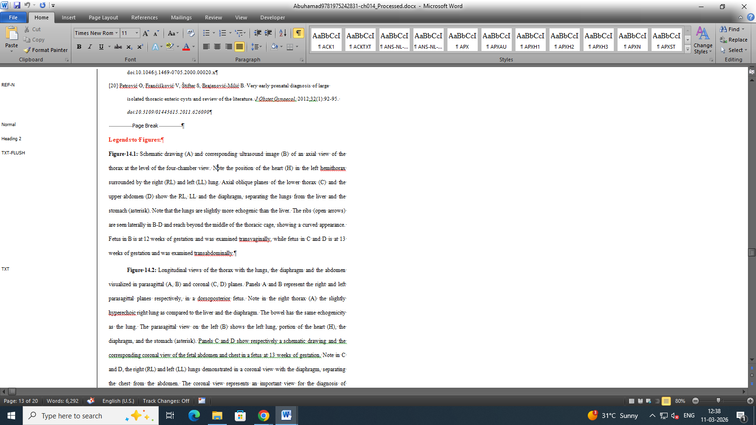

- PMI style applied Table 1
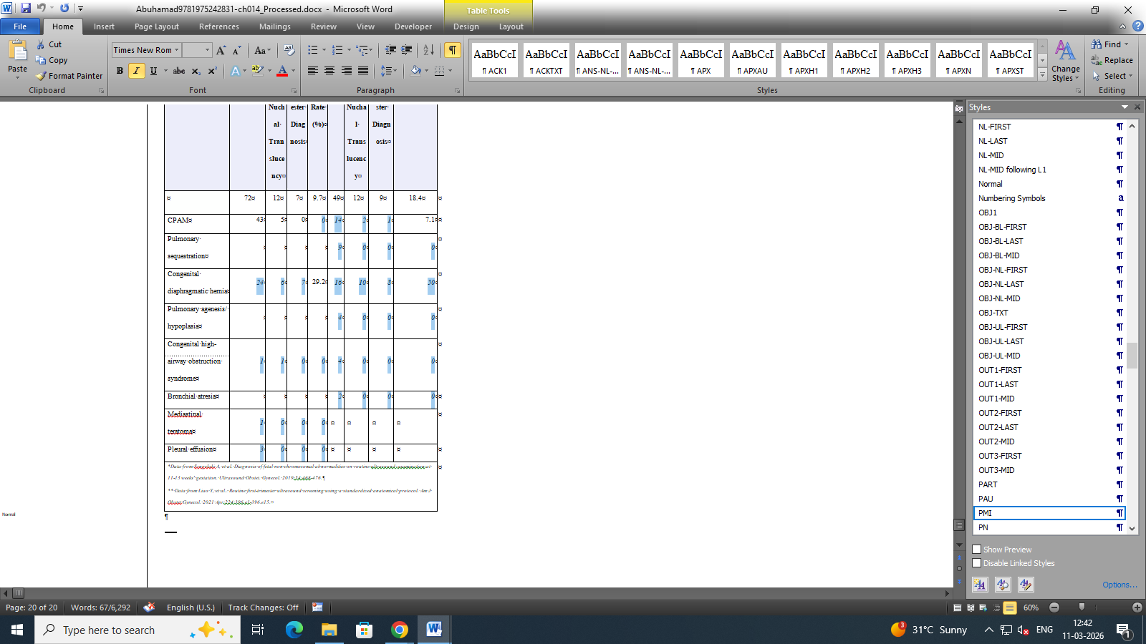
chapter 18 & 20: repeated error also here format issue.

chapter 23:
- BL-LIST TO TXT
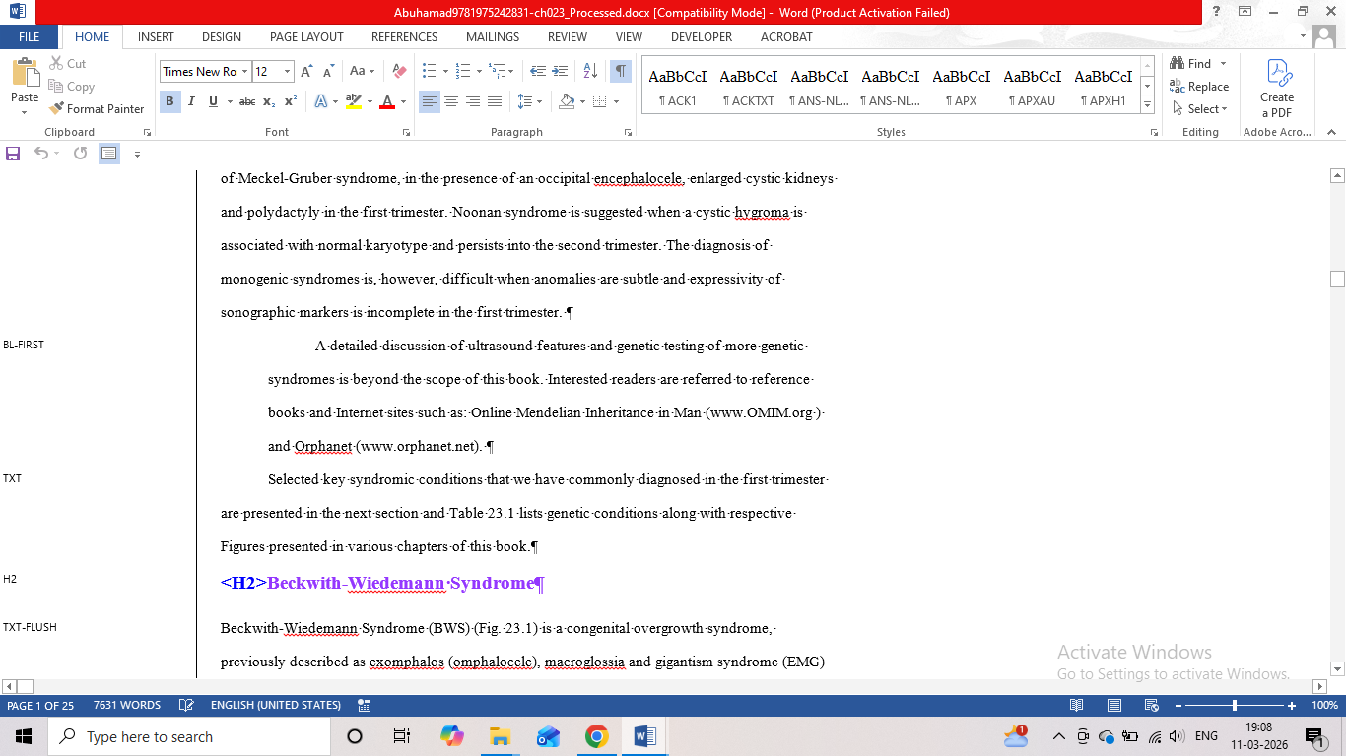
- If TABLE & FIGURE HEADING presented after reference it should be “PMI”

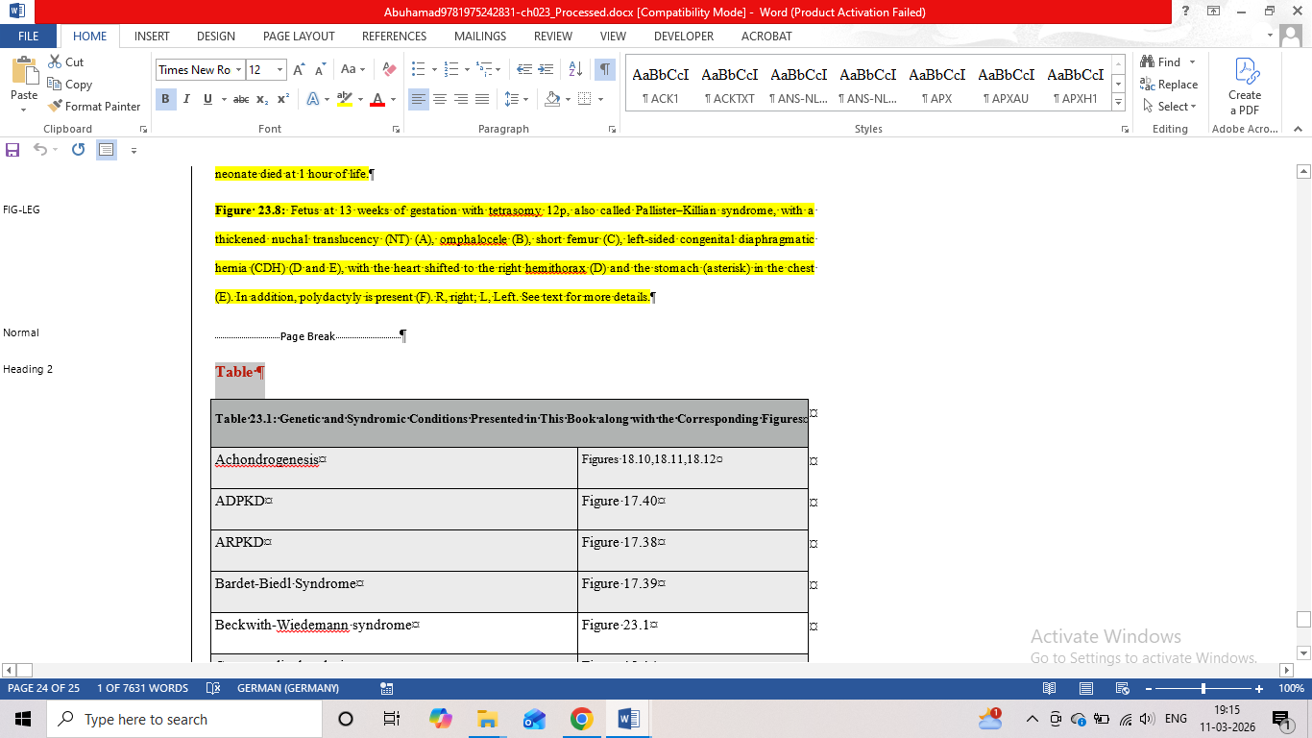

PROJECT NAME: Biller_187567
CHAPTER 1
- CN To SN
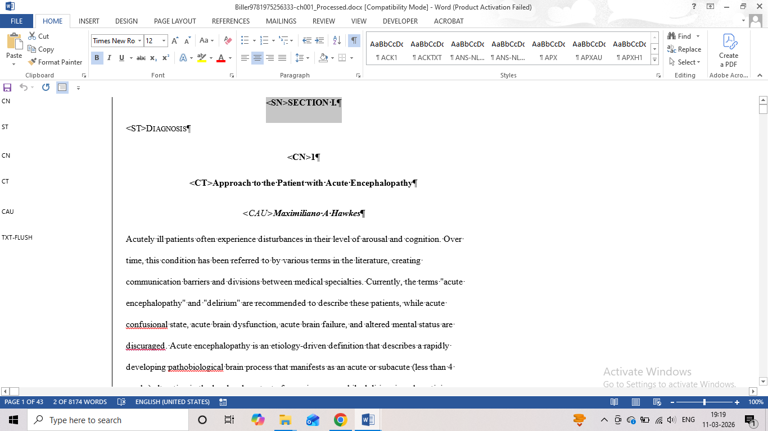

- BL TO NL
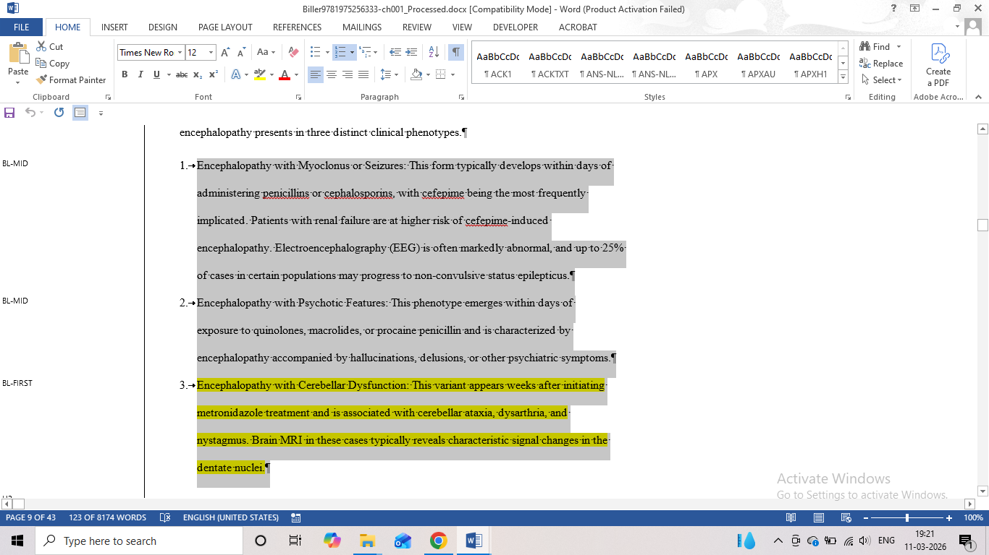

- SRH1 TO REFH1
- SR TO REF-U
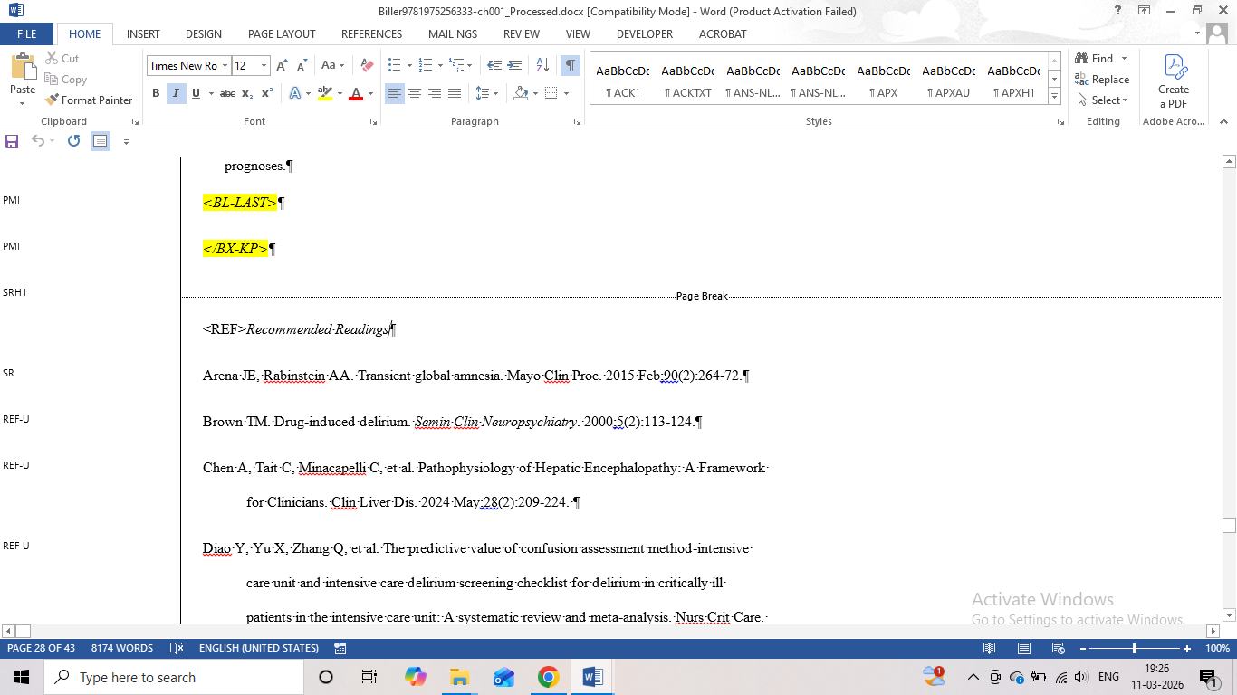

CHAPTER 3
- NL TO LL
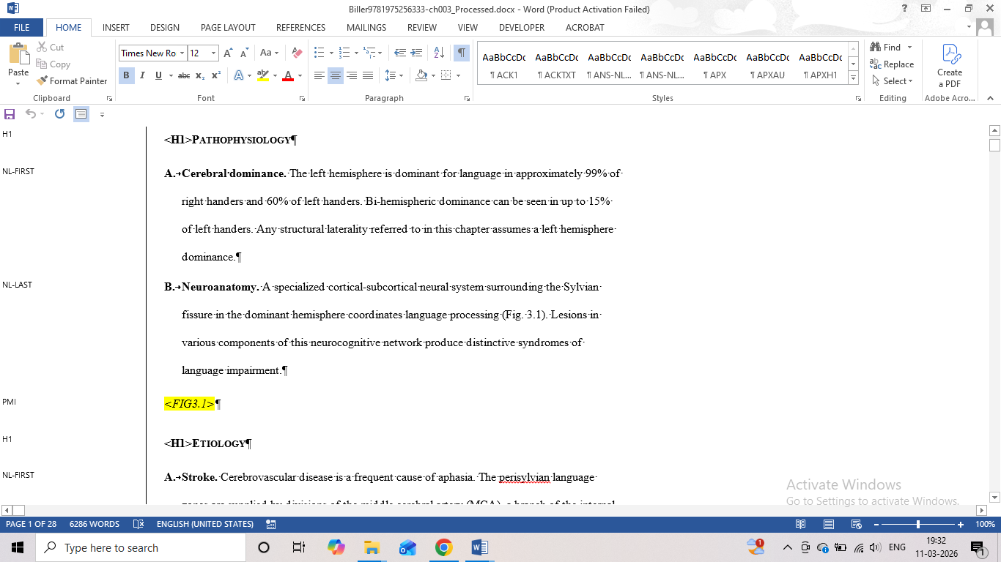

- SUBLIST NL2-MID TO BL2-MID
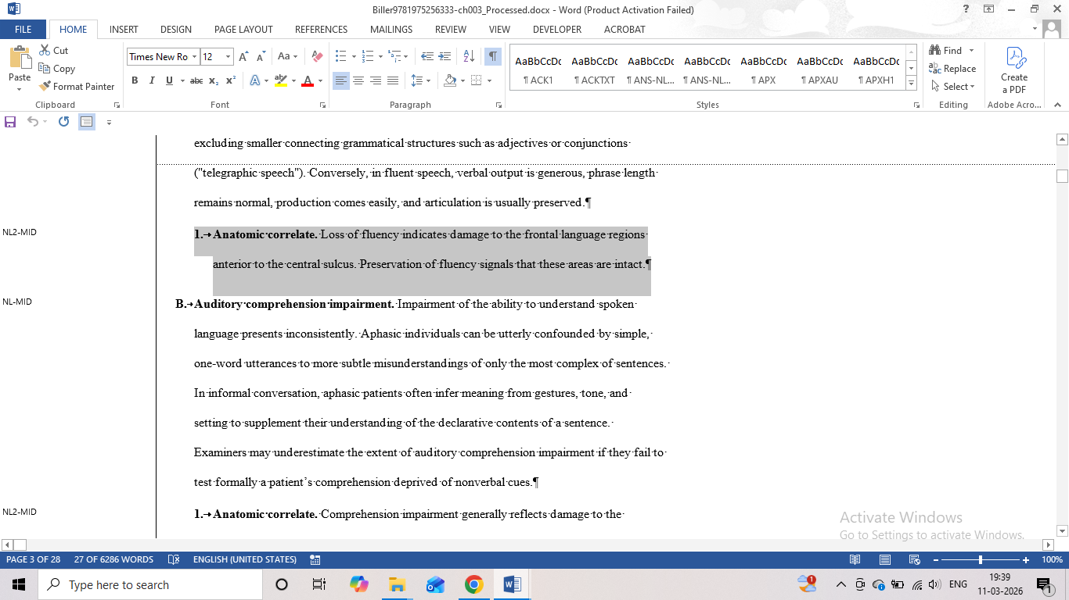

- NOT NECESSARY SUBLIST FIRST & LAST
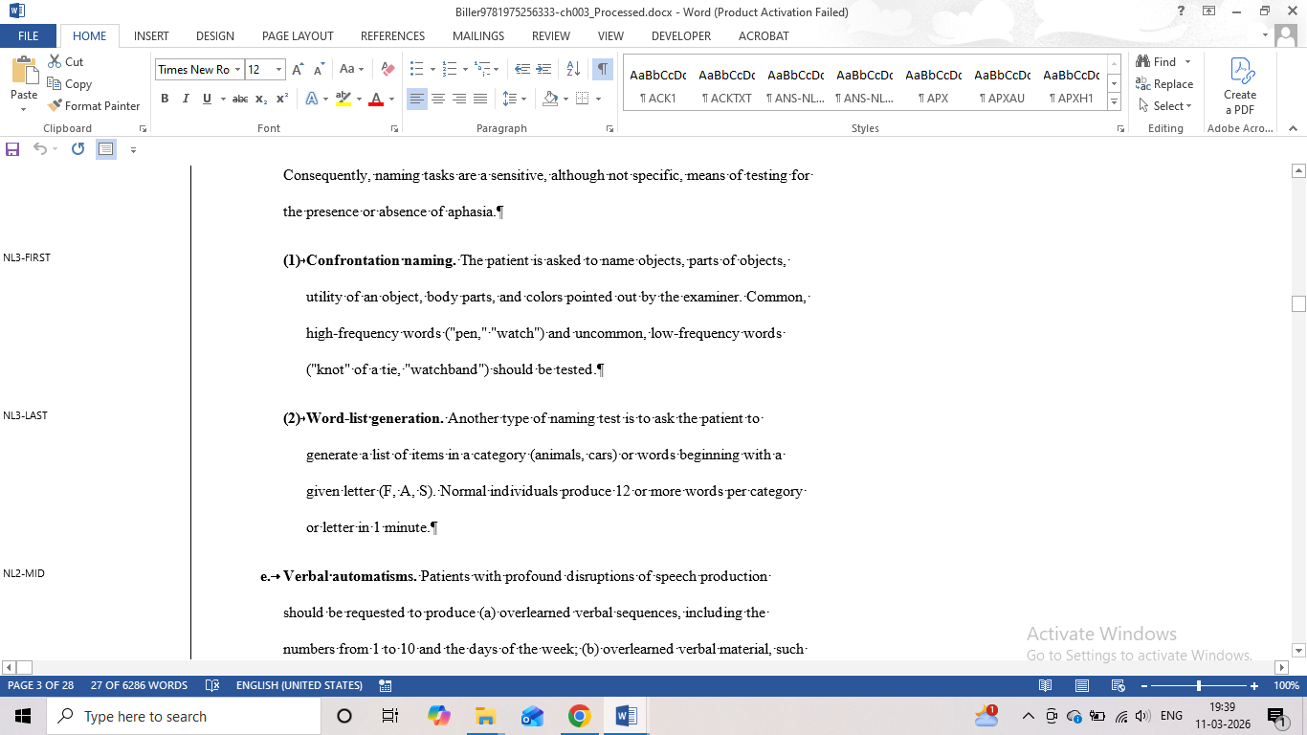

- H4 TO LL-LIST
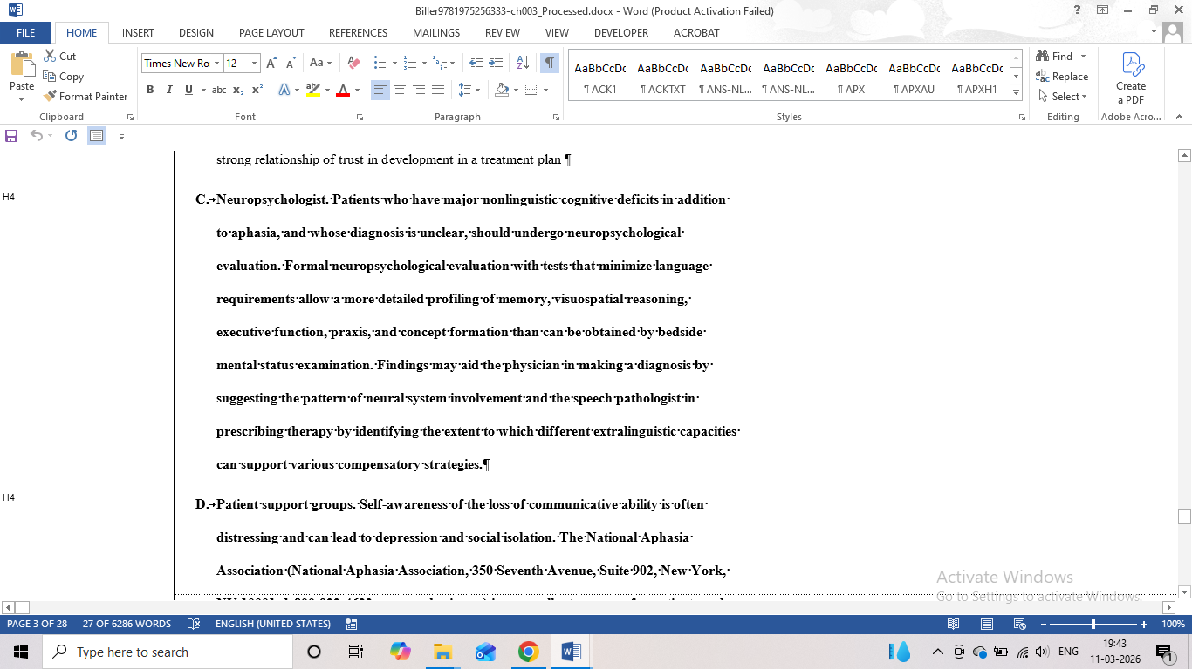

Chapter 8
- list continues text followed TO LL-TXT
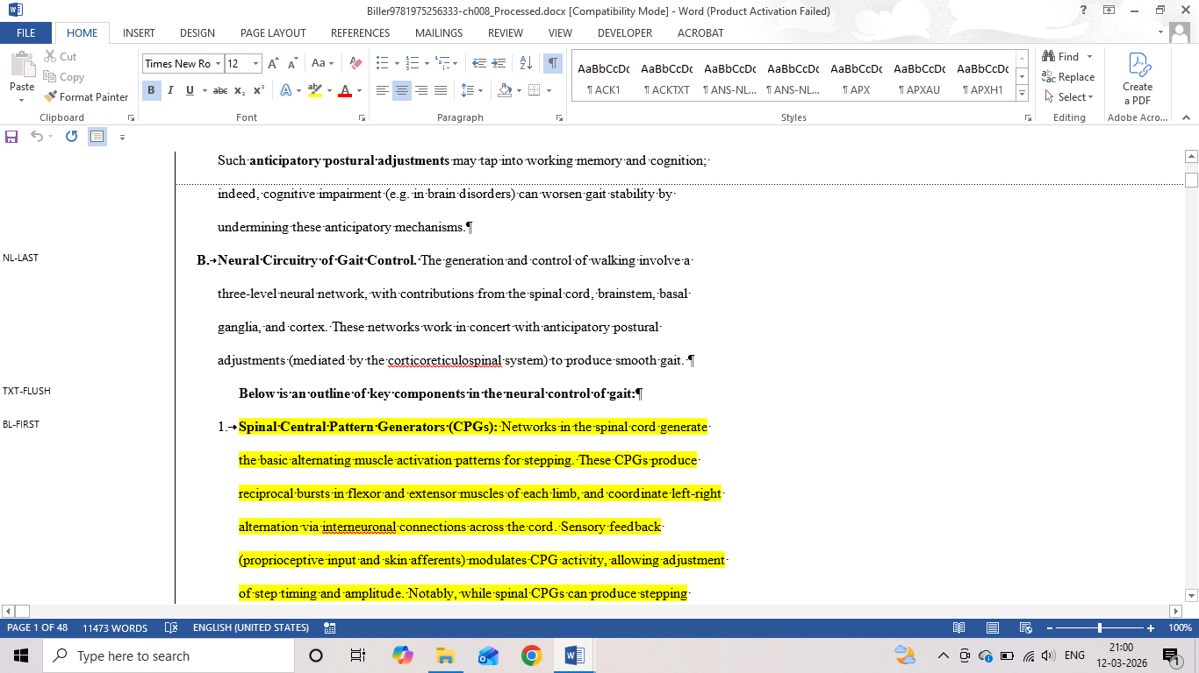
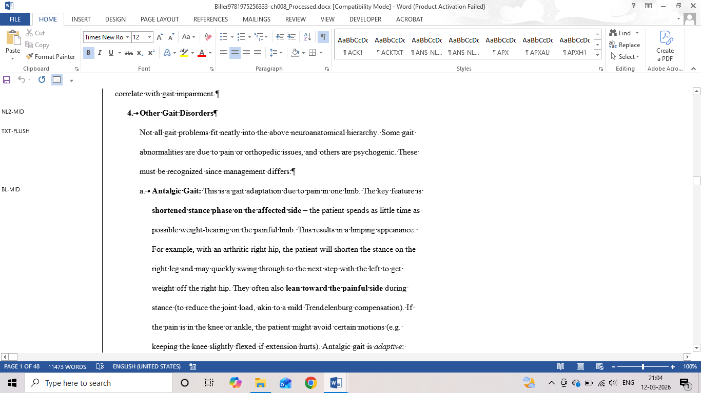
- update fig-src capture
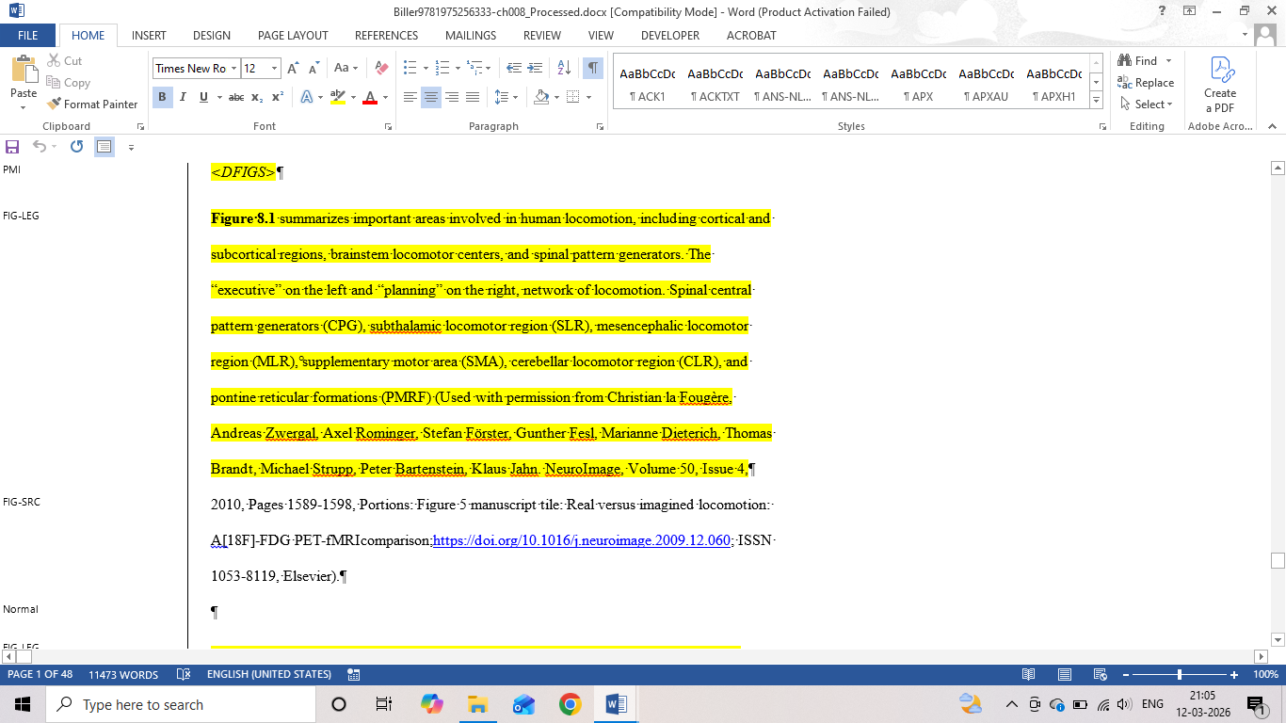

- TXT to TFN
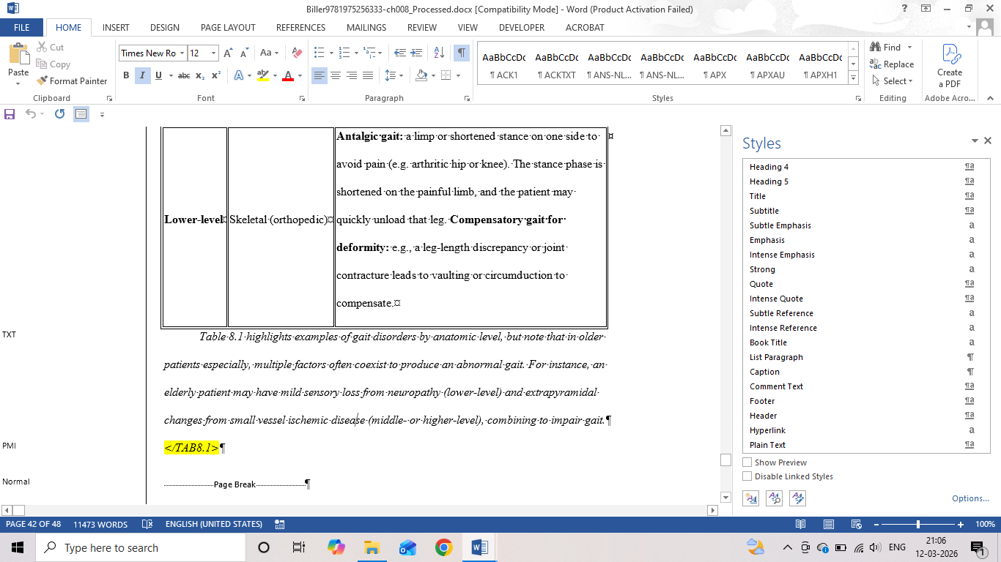

Chapter 9

- PMI
